

SIEM and SOAR Assessment Report

DISM/2B/03

AHMED SHAHEED

Security Policy and Incident Management

**Content Page**

Introduction 3

Splunk 4

IBM QRadar 26

Microsoft Sentinel 36

FortiSIEM 44

Our chosen SIEM product 50

Splunk Log Management 51

References 60

APPENDIX A – TASK BREAKDOWN 63

APPENDIX B – DECLARATION OF ACADEMIC INTEGRITY 68

Declaration of Academic Integrity 70

# Introduction

In today’s rapidly evolving digital landscape, the need for robust cybersecurity measures is more critical than ever. Organizations face a growing number of sophisticated threats, ranging from malware attacks to unauthorized network intrusions. For Vortex Pte Ltd, a small and medium enterprise (SME) specializing in IT support and managed services, these challenges are compounded by their handling of sensitive client data and reliance on remote work environments. Recent incidents, including malware introduced via USB devices and unauthorized access attempts, have underscored the urgent need for a comprehensive Security Information and Event Management (SIEM) solution.

This report will examine and evaluate the top 3 leading SIEM solutions featured in Gartner's 2024 Magic Quadrant: Splunk Enterprise, IBM QRadar, and Microsoft Sentinel. Additionally, we will assess a new challenger, Fortinet FortiSIEM. The goal is to recommend the most suitable option for Vortex Pte Ltd. Each solution will be analyzed based on design principles, architecture, functionalities, strengths, and limitations. Furthermore, the report will propose a solution architecture designed for efficient log collection and analysis from 200 endpoint devices, ensuring effective detection and response to security incidents.

Recognizing that technology alone cannot address all cybersecurity challenges, this report also outlines a tailored incident response plan for Vortex Pte Ltd. By combining advanced SIEM capabilities with structured response protocols, this plan aims to strengthen the company’s cybersecurity posture, minimize risks, and safeguard its operations and client trust.

SIEM Products

# Splunk

Design Principle

Splunk is ranked #1 for the fourth year in a row in the IDC Worldwide Security Information and Event Management Market Shares, 2023: The Leaders in SIEM City (doc # US52525024, September 2024) report. This recognition comes at the heels of Splunk being named as a Leader ten times in a row in the 2024 Gartner® Magic Quadrant™ for SIEM. Additionally, Splunk was ranked first in every Use Case in the 2024 Gartner® Critical Capabilities for Security Information and Event Management.

Splunk is designed to deliver high performance, reliability, and extensibility, empowering organizations to harness the power of their data. Splunk’s design principles center around making data accessible, actionable, and insightful. A key aspect of this is its data-centric approach. Splunk is able to ingest data from virtually any source regardless of format or structure and processes it in real-time. This allows for immediate analysis and insights, even with massive data volumes.

Splunk is built on the principles of scalability, extensibility, and actionable insights, making it a powerful tool for organizations requiring advanced data handling capabilities. Splunk’s scalable architecture supports businesses of all sizes, from small operations to large enterprises, by efficiently managing vast volumes of data generated across IT and operational environments.

Extensibility is a core feature of Splunk, as it integrates seamlessly with third-party software through its extensive ecosystem of APIs and partnerships with cloud service providers, security tools, and IT management systems. This ensures that organizations can use Splunk as part of a cohesive security framework. Furthermore, Splunk emphasizes real-time data analysis, offering cybersecurity teams actionable insights to identify, investigate, and mitigate threats swiftly and effectively.

Architecture

Splunk’s architecture consists of key components tailored to robust data handling and security operations. Some of its key functional components include, but not limited to:

* Data Collection and Indexing: Splunk captures and indexes data from various sources, including logs, metrics, and application data.
* Search and Reporting: Its proprietary Search Processing Language (SPL) powers data queries and analytics.
* Machine Learning Toolkit: Enables predictive analytics and anomaly detection.
* SOAR Integration: Security orchestration and automation for response management.

**Resource Requirements**:

Splunk deployments can vary from lightweight setups for small teams to resource-intensive configurations for large enterprises. On-premises deployments may require multiple servers for indexers, search heads, and forwarders, depending on the scale of data ingestion. The following are Splunk’s minimum software and hardware requirements, according to Splunk Documentation (2024):

Forwarders versions

The Splunk Data Stream Processor officially supports Splunk Forwarders 7.0 and above.

Browser versions

The Splunk Data Stream Processor officially supports these browsers:

* Chrome 77.0 and above
* Safari (latest)
* Firefox (latest)
* Microsoft Edge 12 and above

Operating system versions

DSP will generally work on newer versions of Linux Operating Systems, but it is only officially tested on the OS versions available at the time of release. Any exceptions will be listed in the [Known issues for DSP](https://docs.splunk.com/Documentation/DSP/1.4.6/ReleaseNotes/Known) page.

DSP has been tested and validated on the following OS versions. In all cases, Linux kernel version 3.10.0-1127 or higher is required.

* Amazon Linux 2
* Centos: 7
* Red Hat: 7 and 8
* Ubuntu: 20.04 or 22.04 LTS
* ***Centos 8 has reached end of life on December 31st, 2021. See [CentOS Linux EOL](https://www.centos.org/centos-linux-eol/) for more information.

Splunk Enterprise versions

The Data Stream Processor officially supports sending data to Splunk Enterprise 7.1.0+ instances hosted on Linux.

Hardware Requirements

The clustered deployment must have a minimum of three nodes with each node having the following specifications. Splunk recommends having at least five nodes for higher availability. Figure 1.2 below illustrates the necessary hardware requirements in order to run Splunk.

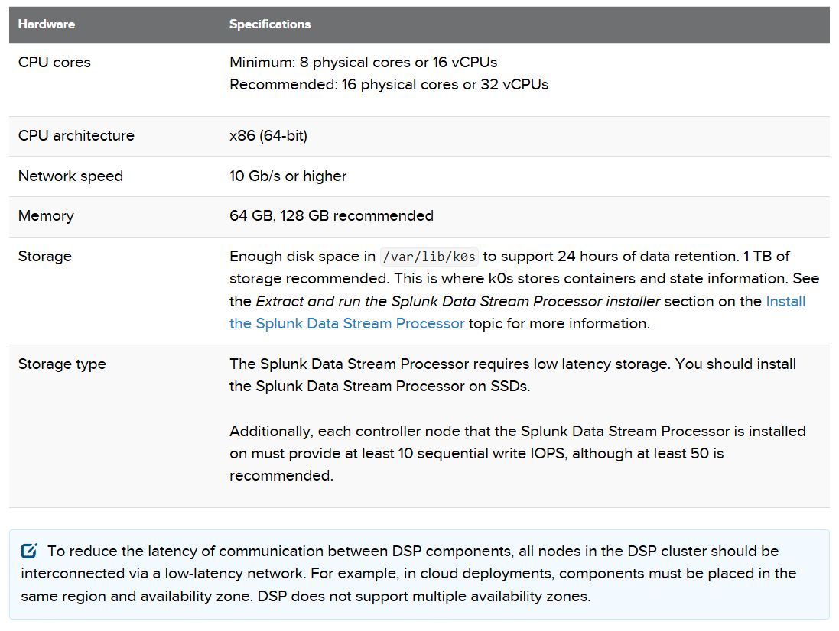

*(Splunk Documentation, 2024)*

Figure 1.1

Splunk will also require some port configurations according to Splunk Documentation (2024).

Cluster Ports

These ports shown in figure 1.3 are used for cluster operation and should be open between cluster nodes.

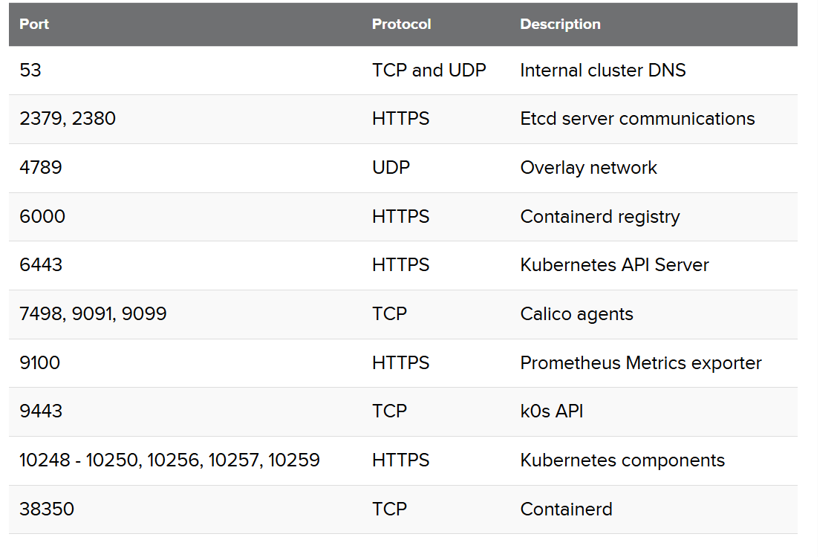

*(Splunk Documentation, 2022)*

Figure 1.2

External Ports

Starting from DSP 1.4.0, all external HTTP traffic will be routed through the standard HTTP port 443. The following ports shown in figure 1.4 are used by end users outside of the cluster. Not all cluster nodes need to be exposed, but the node externally accessible needs to have the following ports open.

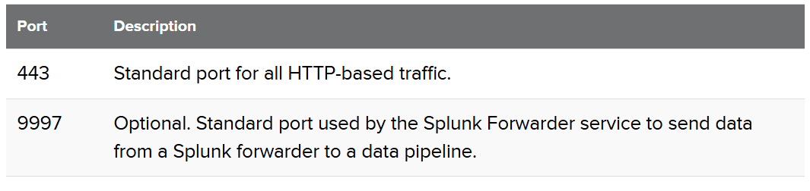

*(Splunk Documentation, 2022)*

Figure 1.3

**Cloud Deployment:**

Splunk is available as an on-premises solution, a fully SaaS-based model through Splunk Cloud, or in hybrid environments. This flexibility enables organizations to choose a deployment model aligned with their infrastructure and compliance requirements.

The Splunk Cloud Platform lets you investigate, monitor, analyze and act on your data with unprecedented insight, all from the cloud. Splunk Cloud eliminates the need for organizations to maintain on-premises hardware, significantly reducing infrastructure management overhead. This model is especially advantageous for businesses like Vortex Pte Ltd, which require the ability to scale seamlessly as their data ingestion needs grow without incurring the capital expenses associated with on-premises deployments.

One of Splunk Cloud's standout features is its ability to integrate directly with a wide variety of cloud platforms, including Amazon Web Services (AWS), Microsoft Azure, and Google Cloud. This integration capability ensures smooth data ingestion from cloud-native applications, infrastructure logs, and other external sources. Splunk Cloud also provides pre-built connectors and APIs that allow organizations to aggregate data from hybrid environments, where part of the infrastructure is on-premises and part is in the cloud. This makes it a powerful solution for enterprises transitioning to cloud environments or operating complex hybrid setups. Figure 1.5 below shows an example usage of Splunk Cloud from a remote location.

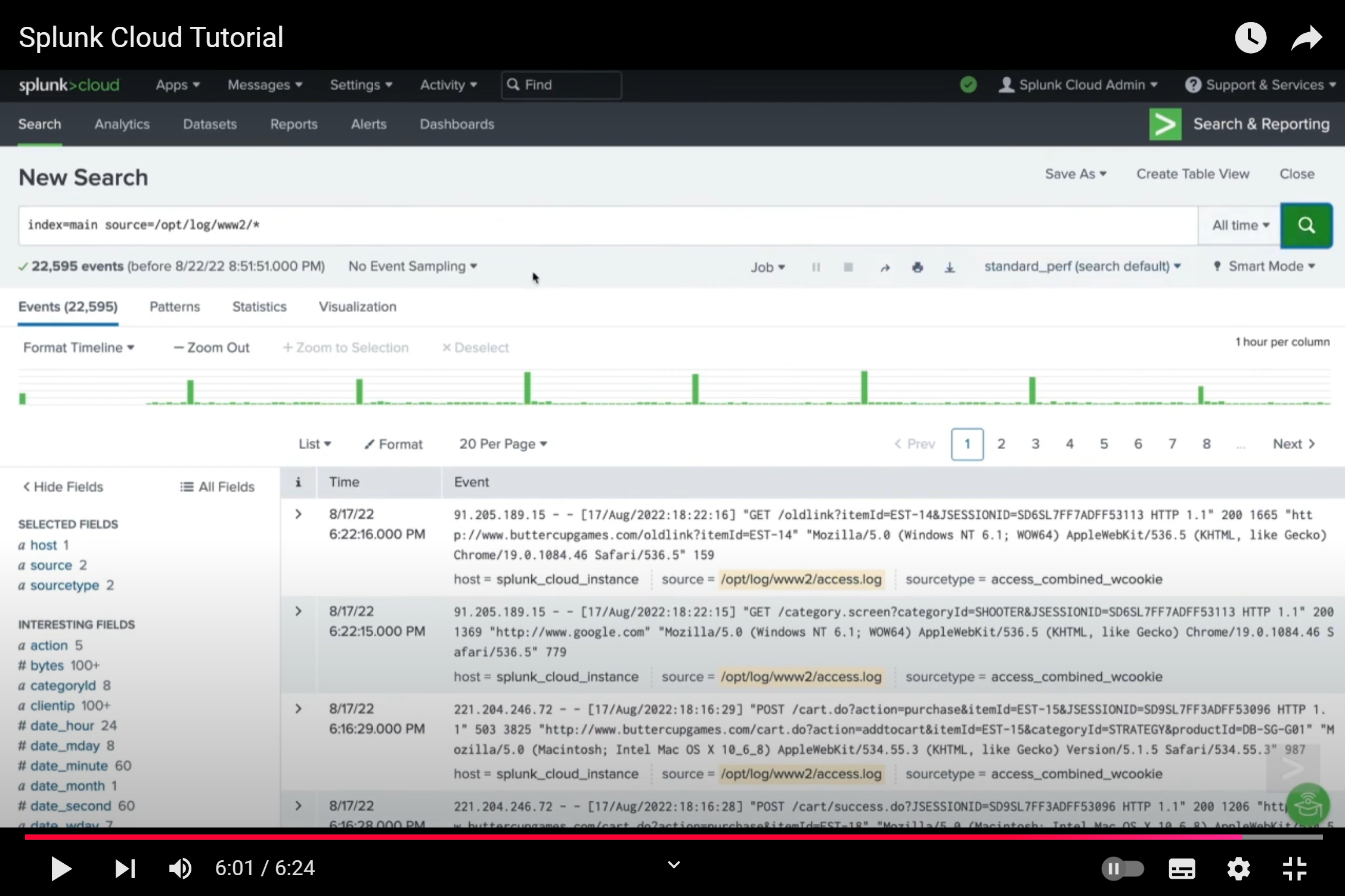

*(Splunk, 2022)*

Figure 1.4

In the search query above index=main source=/opt/log/www2/*, index=main indicates that the search will be performed on the index named "main". source=/opt/log/www2/* will further refine the search to only include events that originate from the specified file path /opt/log/www2/*. This part specifies that the search should include events from any file within the /opt/log/www2/ directory. The wildcard character * matches any file name within that directory, so this command tells Splunk to search the entire directory for events originating from any file within the directory. This includes multiple log files, such as access logs, error logs, and other relevant files.

Splunk has also developed Splunk Mobile, a mobile phone application available on both IOS and android devices. Splunk Mobile let’s you securely access your Splunk data on-the-go. You can get notified with actionable alerts while away from your desk and make decisions faster with dashboards and reports at your fingertips, allowing the user to take action from anywhere. Figure 1.6 below shows an example of the Splunk Mobile application.

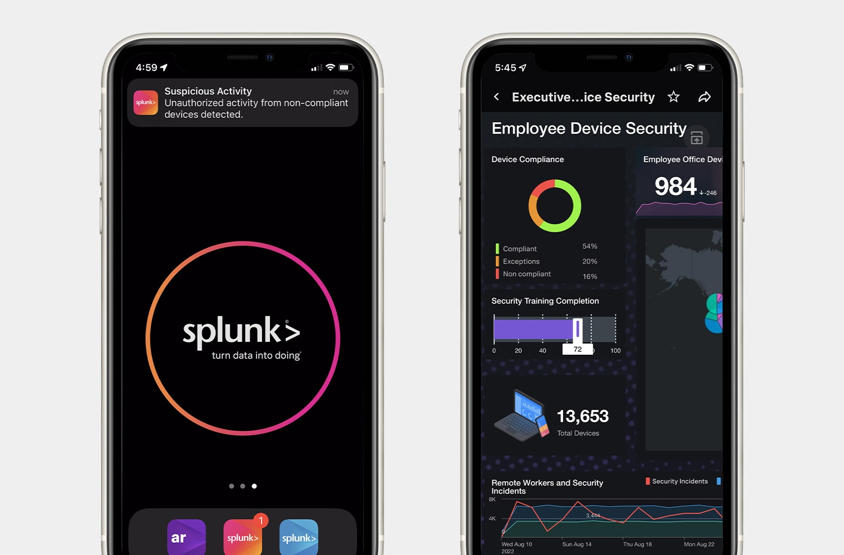

*(Splunk, 2024)*

Figure 1.5

The cloud deployment will look like the diagram shown in Figure 1.7 below. You will need to install a universal forwarder for metrics and logs collection on Windows systems. Install a universal forwarder for logs collection and collectd for metrics collection for unix systems. You have to install universal forwarder credentials on every system you install a universal forwarder on. Data the universal forwarder collects is sent to the indexing tier in the cloud environment. Diagram 1.7 demonstrates a cloud environment that is ingesting data from a Windows system, a Mac system, a Linux system, and a heavy forwarder for AWS data collection.

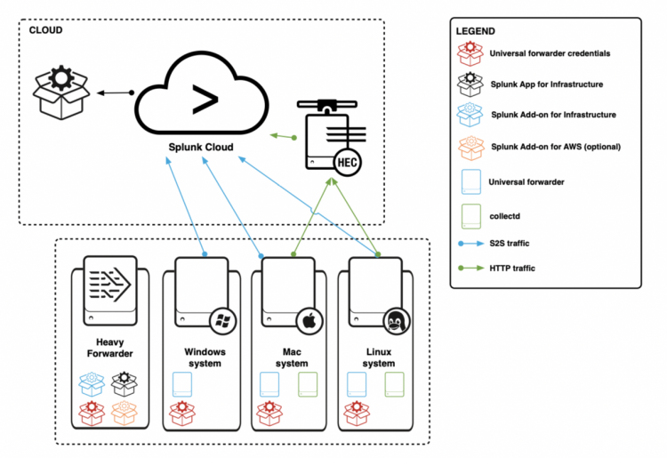

*(Splunk, 2020)*

Figure 1.6

Overall, Splunk Cloud helps to reduce the amount of the time required from different resources of internal security. It also helps to reduce the cost for every daily ingests of GB on SIEM by about 33%. It also allows us to simply migrate to the model of SOC at a lower cost.

**Data Storage**

Splunk’s data storage system is designed to efficiently manage and organize vast volumes of data while maintaining scalability and cost-effectiveness. Data ingested into Splunk is divided into buckets based on its age and relevance, with each bucket serving a specific purpose in the data lifecycle. These buckets include hot, warm, cold, and frozen buckets, which ensure a tiered approach to data retention and accessibility. The actual retention periods for your buckets will depend on your specific Splunk configuration, organisations can adjust the retention settings for each index to meet their data retention policies.

* Hot Buckets: These store the most recently indexed data and are actively written to. Hot buckets allow for immediate access to the latest data, making them crucial for real-time monitoring and rapid threat detection. Typically, data stays in hot buckets for a short period, usually a few days.
* Warm Buckets: When data ages out of the hot bucket, it moves to warm storage. While still searchable and accessible, warm buckets are optimized for slightly less frequent access compared to hot data. The retention period for warm buckets can vary, but it's typically longer than for hot buckets, such as a few weeks or months.
* Cold Buckets: Cold storage holds older data that is not frequently accessed but remains searchable for historical analysis. This tier balances cost and accessibility, allowing organizations to retain searchable archives without the higher costs associated with hot and warm storage. Cold buckets are stored on the cheapest storage tier, often in cloud storage. The retention period for cold buckets can be several years or even indefinite, depending on the organization's data retention requirements.
* Frozen Buckets: Data in frozen storage is archived and no longer directly accessible in Splunk for searches. However, frozen data can be retained for compliance, audits, or forensic investigations. Organizations can also define policies for exporting frozen data to external storage systems, such as cloud-based object storage or tape archives, to further reduce costs.

This tiered approach enables Splunk to optimize storage costs by reserving high-performance resources for active data while offloading older data to cost-efficient storage tiers. Splunk also incorporates indexed data compression, which reduces the overall storage footprint while maintaining data integrity and searchability.

In cloud deployments, Splunk utilizes elastic cloud storage to dynamically scale storage capacity as data volumes grow or shrink. This flexibility ensures that organizations do not need to overprovision resources, significantly reducing costs. Splunk Cloud also supports integration with third-party cloud storage solutions, such as Amazon S3 or Azure Blob Storage, for long-term data retention and compliance purposes.

Splunk's data storage design is not only scalable but also ensures that data is stored securely. Encryption is applied both in transit and at rest, meeting stringent compliance standards for data protection. With its sophisticated tiered storage and cloud integration capabilities, Splunk enables organizations to balance performance, cost, and compliance while managing their growing data needs effectively.

**Event searching**

Splunk offers flexible visualization and powerful search query tools using its own Splunk Search Processing Language (SPL), similar to using regular expression to pipe out the necessary information, users can query and analyze data in real-time and create custom rules and visualizations to explore data in various ways, through charts, graphs, and tables and specific time windows just to name a few examples. Splunk now utilizes machine learning algorithms to automate data analysis and identify patterns and anomalies. Splunk’s intuitive interface is designed to be easy to use, even for non-technical users. It offers customization options to tailor the environment to specific needs and preferences.

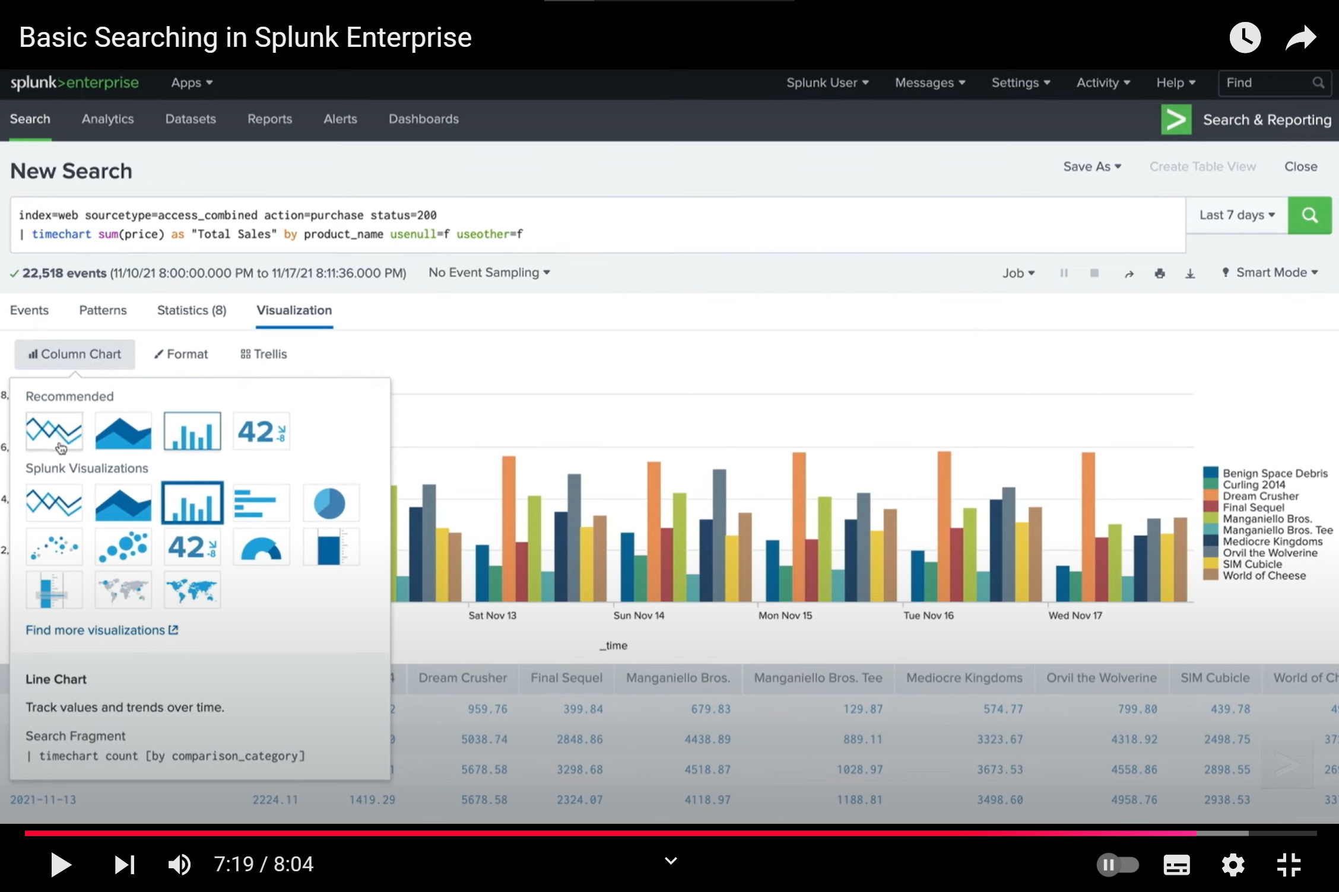

*(Splunk How-To, 2022)*

Figure 1.7

Figure 1.7 above shows an example usage of Splunk. In this example, this command index=web sourcetype=access_combined action=purchase status=200 | timechart sum(price) as "Total Sales" by product_name usemul=f useother=f extracts purchase data from the web server logs, calculates the total sales for each product over time, and visualizes the results in a timechart. This command performs a time-based analysis of purchase data from a web server, specifically focusing on successful purchases (status 200). It breaks down the total sales by product name over a specified time period (in this case, the last 7 days). The search terms index=web specifies that the search should be limited to data from the "web" index, sourcetype=access_combined then further limits the search to events with the "access_combined" source type, typically associated with web server access logs. action=purchase status=200 then filters the events to only those where the action is "purchase" and the status code is 200 (indicating a successful transaction).

You may customize the timechart even further by adding options like span to control the width of the time bins and fixedrange to fix the time range. Additionally, Splunk supports federated search, allowing users to query data across multiple Splunk instances or external data repositories, further enhancing its search flexibility.

To support efficient event searching, Splunk employs indexed data compression, which reduces the overall storage footprint while maintaining high-speed search capabilities. The system also uses metadata tagging during the indexing process, enabling faster retrieval by narrowing searches to specific criteria such as timestamps, event types, or source identifiers. With built-in search optimization techniques, Splunk ensures that even complex queries can be executed with minimal latency, making it a powerful tool for real-time monitoring and threat detection.

**Main functionalities**

Log management

One of Splunk’s primary functions is its advanced log management capabilities. Splunk collects, aggregates, and normalizes log data from a wide range of sources, including servers, endpoints, cloud platforms, network devices, and applications. The platform uses its proprietary indexing system to organize and store logs efficiently, enabling quick access for real-time monitoring and historical analysis. Splunk’s log management supports structured and unstructured data, making it ideal for diverse IT environments. This capability allows organizations to consolidate disparate data sources into a unified view, reducing the complexity of managing security events across multiple systems. The figure 1.8 below shows a screenshot of Splunk’s log management using Splunk’s Log Observer Connect.

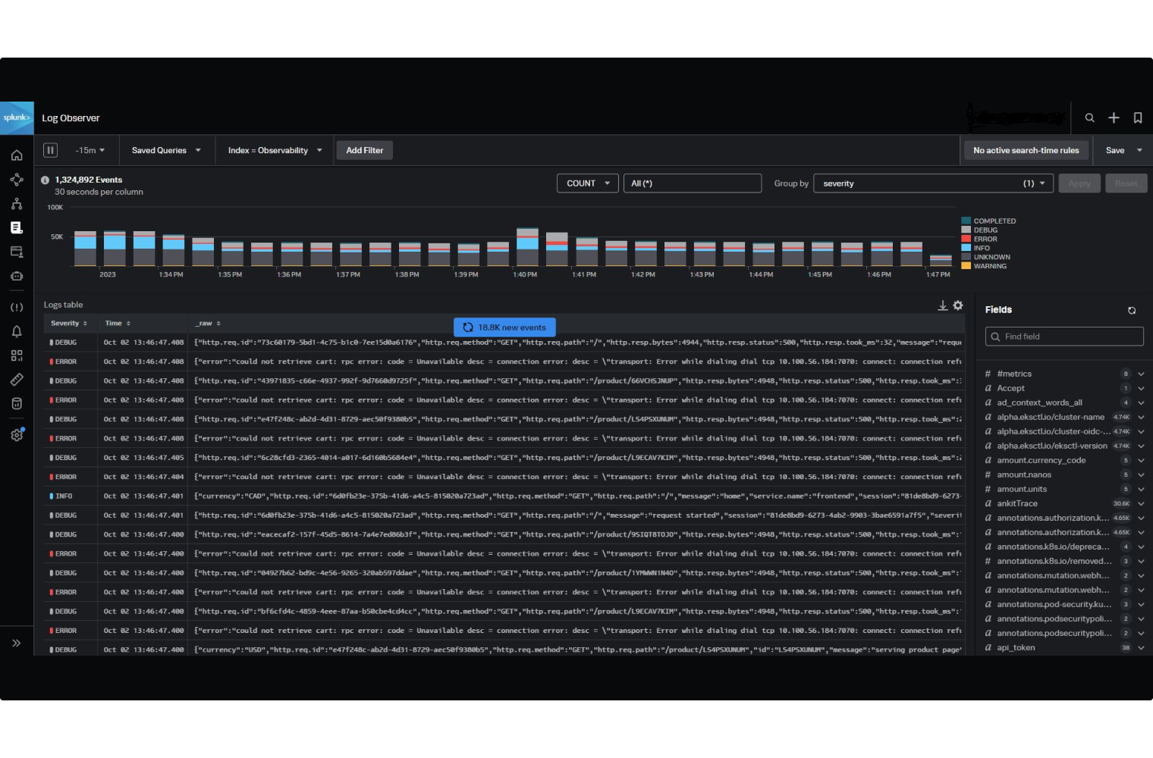

*(Splunk, n.d.)*

Figure 1.8

Threat detection

Splunk excels in threat detection by leveraging powerful analytics and real-time monitoring capabilities. Splunk allows security teams to set customizable alerting rules to detect specific patterns or Indicators of Compromise (IoCs), such as unusual login attempts, unauthorized access, or network anomalies. Splunk’s machine learning toolkit enhances threat detection by identifying behavioral anomalies, such as deviations in user activities or unusual network traffic, which might signal an attack. Additionally, Splunk supports event correlation, linking related security events across systems to provide context and visibility into complex attack scenarios. This capability enables faster identification of sophisticated threats like Advanced Persistent Threats (APTs). Figure 1.9 below shows a screenshot of how to create an alert.

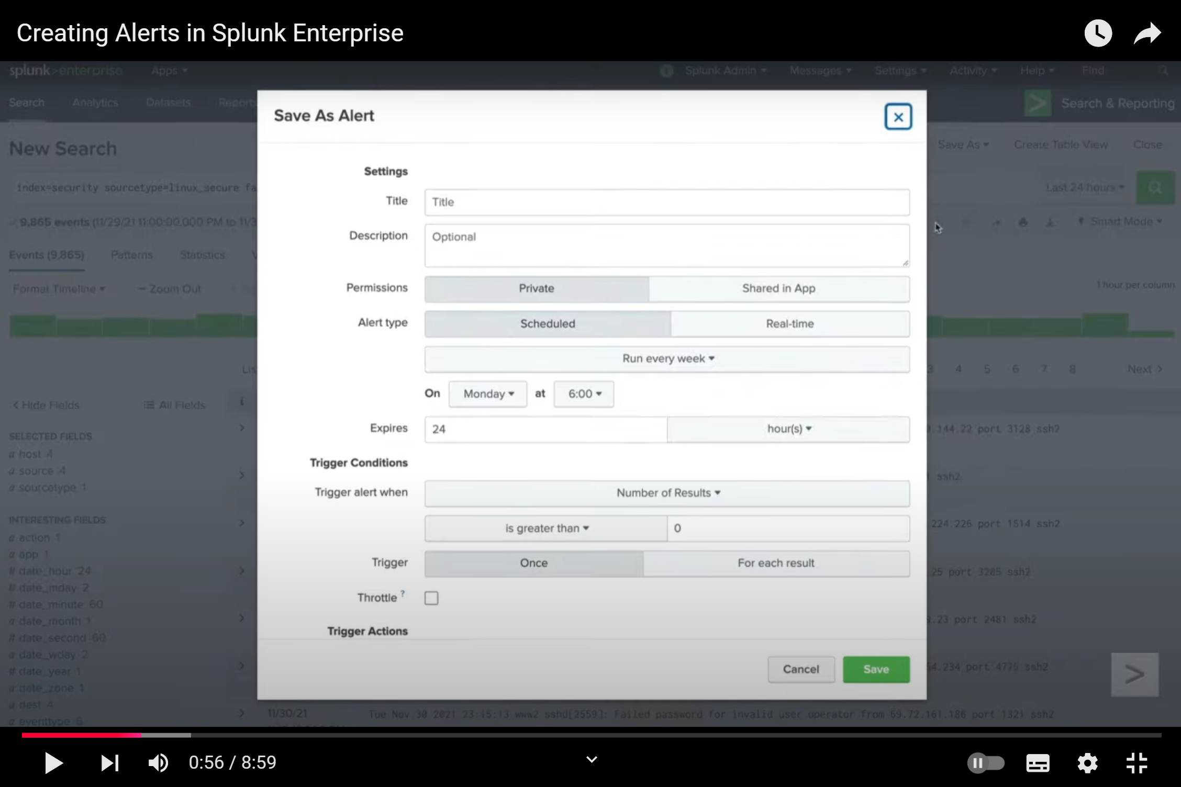

*(Splunk How-To, 2022)*

Figure 1.9

User Behavior Profiling

Splunk incorporates User Behavior Analytics to profile the actions of users, devices, and systems within an organization. By analyzing baseline behavior patterns, Splunk can identify anomalies that might indicate insider threats, compromised accounts, or malicious activity. For example, if a user begins accessing sensitive data outside of their usual working hours or from an unfamiliar location, Splunk can flag these activities as suspicious. The platform’s ability to integrate UEBA with its threat detection and incident response tools enhances its effectiveness in addressing both external and internal security risks. Figure 1.10 below shows an example usage of Splunk User Behavior Analytics

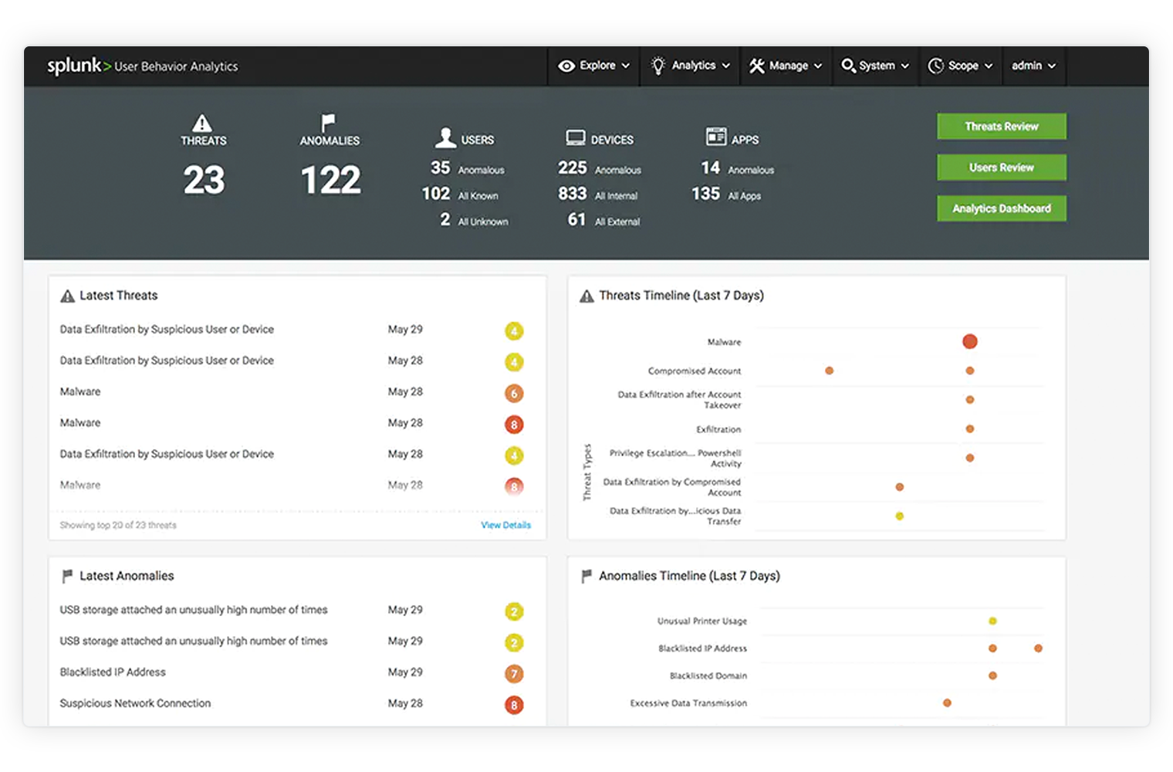*(Splunk, n.d.)*

Figure 1.10

Splunk User Behavior Analytics visualizes threats across multiple phases of an attack to give security analysts a comprehensive understanding of attack root cause, scope, severity and timelines. This context-rich view enables analysts to rapidly assess impact and make informed decisions quickly and confidently. Figures 1.11, 1.12 and 1.13 below demonstrate Splunk’s advanced threat review, threat relations and kill chain graphics respectively.

Splunk User Behavior Analytics automatically reduces billions of raw events down to tens of threats for rapid review, without the need for time-consuming human-fueled detective work performed by an army of highly skilled security and data science professionals.

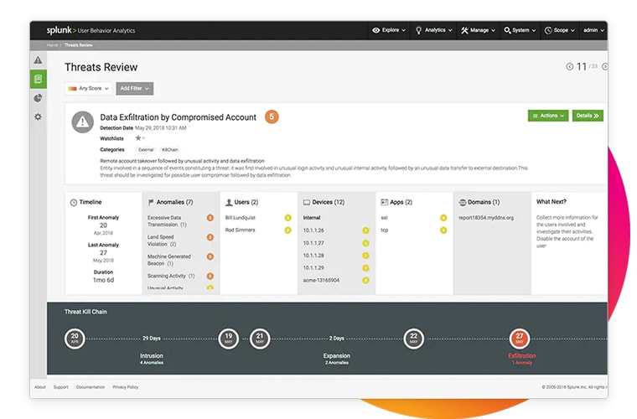

*(Splunk, n.d.)*

Figure 1.11

Using Splunk User Behavior Analytics, users are able to visualize threats over a kill chain to gain context. Anomalies are stitched together across users, accounts, devices and applications so you can clearly see attack patterns.

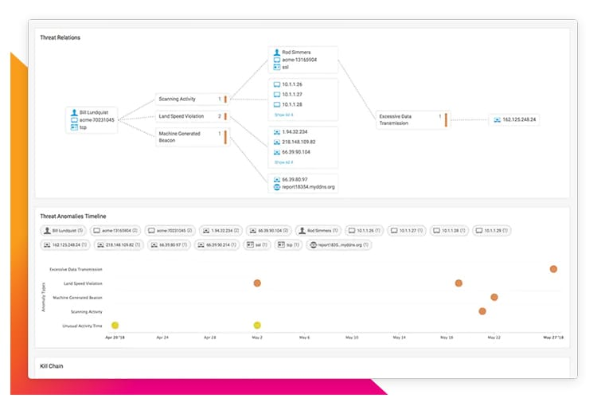

*(Splunk, n.d.)*

Figure 1.12

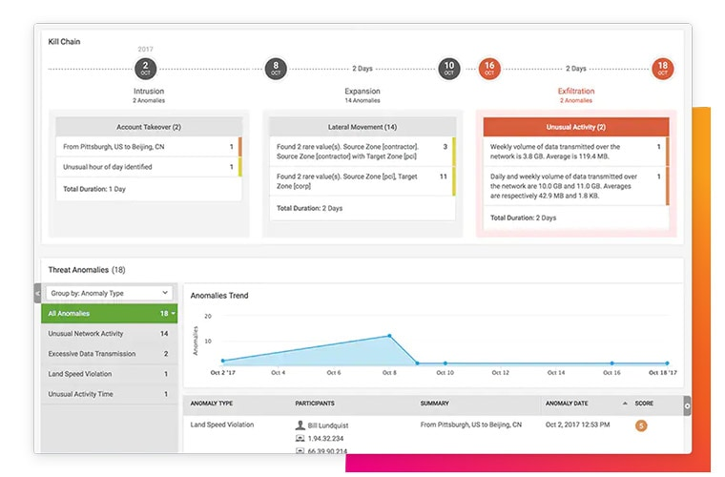

*(Splunk, n.d.)*

Figure 1.13

Using Splunk’s kill chain detection and attack vector discovery, users can detect lateral movement of malware or malicious insider proliferation and see behavior-based irregularities or pinpoint botnet or C&C activity. By analyzing patterns, relationships, and sequences of events, Splunk provides insights into potential attack chains. For instance, it can link multiple failed login attempts on different systems to identify a potential brute force attack. This correlation capability significantly reduces alert fatigue by consolidating related events into actionable insights.

Compliance Management

Reporting on firewall, access control and application logs is difficult and costly. Each of these systems generate logs in different formats and locations. Each auditor request involves a different, manual procedure. Quickly gain real-time posture and insights across all IT resources and security controls to clear compliance and pass audits with minimal effort, regardless of mandate or regulatory framework. Using Splunk, users can collect, search, monitor and analyze data using a centralized solution to meet compliance requirement.

Meet explicit requirements for monitoring, reviewing and retaining logs, configurations and other machine data. Automatically generate ad-hoc reports and automate scheduled searches to answer auditors’ questions. Splunk supports compliance requirements by providing pre-configured templates and tools to generate detailed audit reports. These reports help organizations demonstrate adherence to standards such as PCI-DSS, GDPR, or HIPAA. The platform’s ability to maintain a comprehensive log history and conduct efficient searches ensures that compliance audits can be completed quickly and accurately. Figure 1.14 below shows an example of Splunk’s compliance management console.

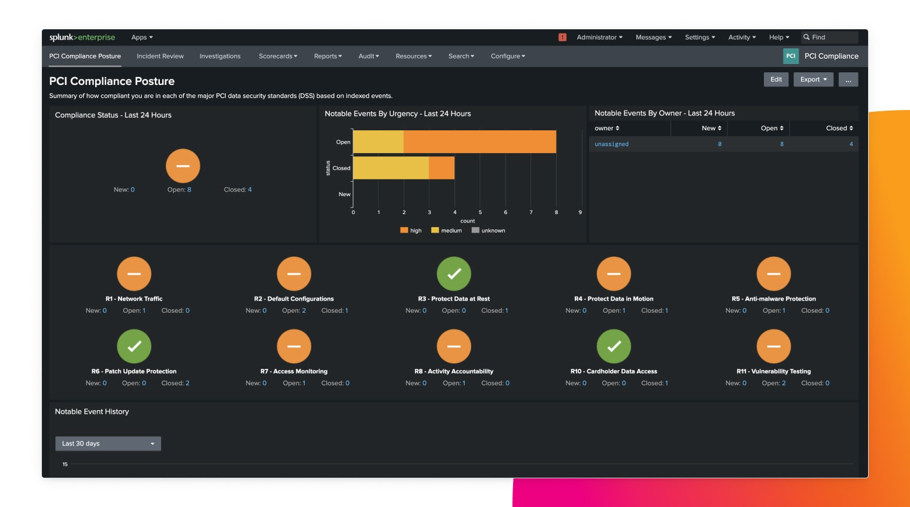*(Splunk, n.d.)*

Figure 1.14

Splunk SOAR

Splunk SOAR (Security Orchestration, Automation, and Response) helps you work smarter by automating repetitive tasks, multiplying your team’s efforts and allowing it to focus its attention on the mission-critical decisions that require its talents. Splunk SOAR can automatically triage events to eliminate noise from your workload, pre-fetch threat intelligence to support your decision-making, and orchestrate complex workflows to improve efficiency and precision.

Splunk SOAR is designed to integrate and enhance your security operations seamlessly. It orchestrates your security stack by connecting with 300+ third-party tools and supporting 2,800+ automated actions. Splunk SOAR capabilities can also be leveraged by your Splunk Enterprise Security deployment for a seamlessly integrated unified workflow experience. This ensures that you can streamline complex workflows across various teams and tools without the need to massively overhaul your existing security stack. Figure 1.15 below shows an example of the available third-party apps supported by Splunk SOAR. Users may also create their own apps using the app wizard shown in figure 1.16

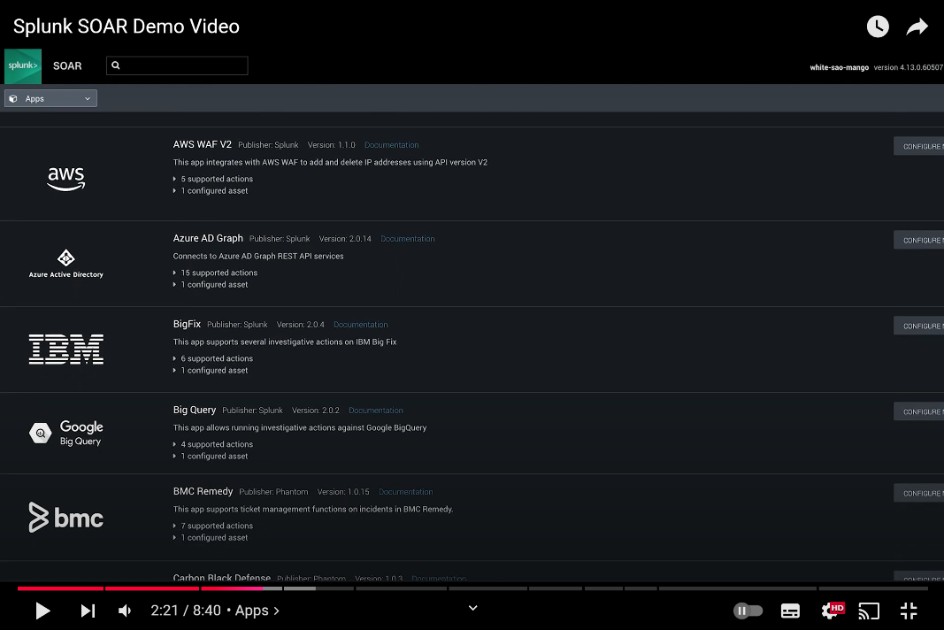

*(Splunk, 2021)*

Figure 1.15

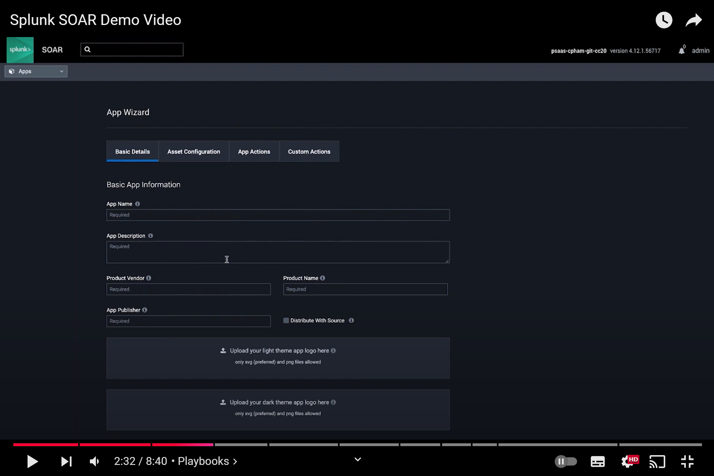

*(Splunk, 2021)*

Figure 1.16

Splunk’s Visual Playbook Editor allows developers to build and edit playbooks with drag and drop ease while constructing a playbook graphically. Splunk SOAR empowers users to easily automate security tasks with playbooks that can be customized to fit your needs. Splunk SOAR features a wide variety of prebuilt playbooks, which leverage the MITRE ATT&CK and D3FEND frameworks. Figure 1.17 below shows an example of using playbooks in Splunk SOAR, while figure 1.18 shows an example of the Splunk Visual Playbook Editor.

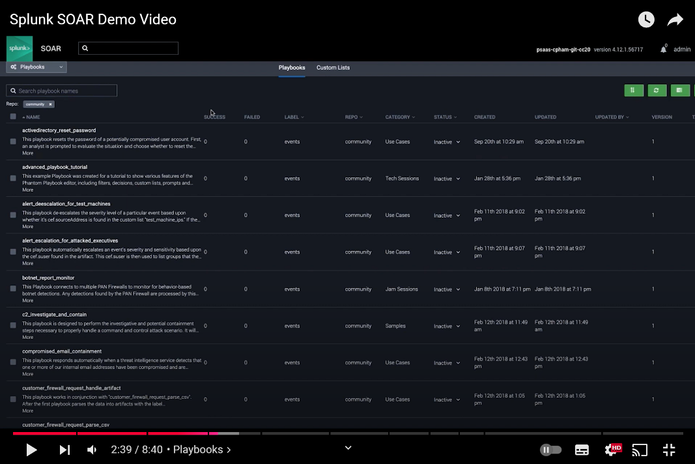

*(Splunk, 2021)*

Figure 1.17

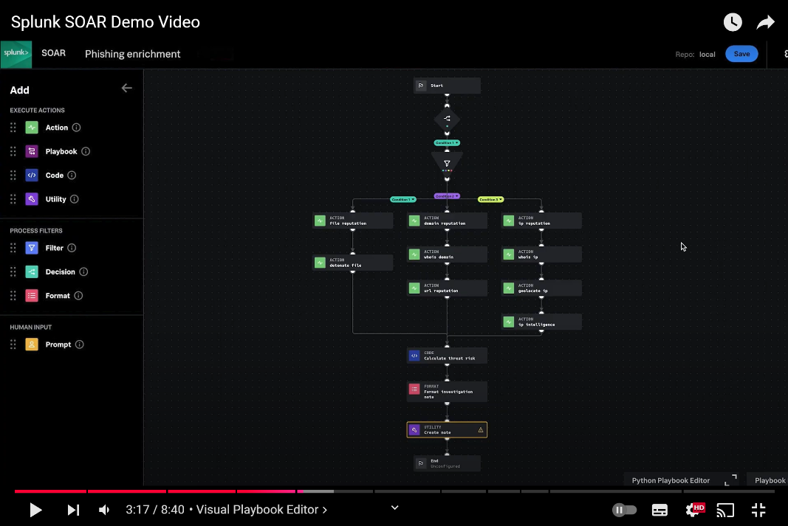

*(Splunk, 2021)*

Figure 1.18

Splunk’s Visual Playbook Editor allows developers to build and edit playbooks with drag and drop ease while constructing a playbook graphically. You can even call another playbook from an existing playbook Figure 1.19 below shows an example of a playbook script written in python utilizing the phantom library.

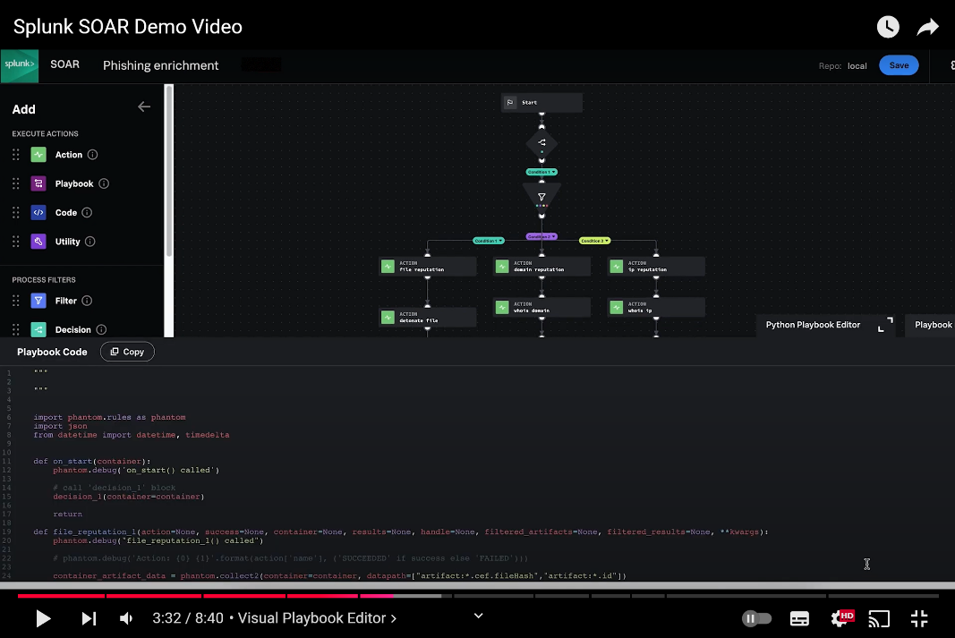

*(Splunk, 2021)*

Figure 1.19

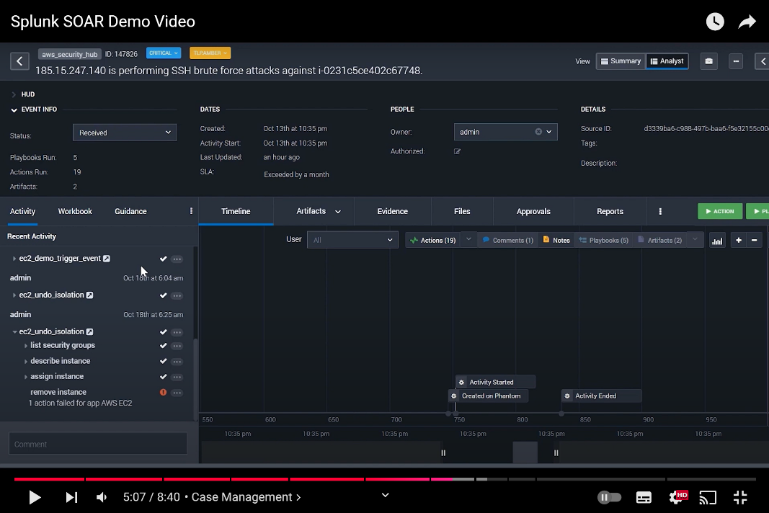

*(Splunk, 2021)*

Figure 1.20

Figure 1.20 above shows an example of Splunks’ SOAR case management. In this example, a SSH brute force attack is detected, specifically from an IP address 185.15.247.140. This event is categorized as ‘Critical’ with tags such as ‘aws_security_hub’ and a unique event ID of 147826. The SLA (Service Level Agreement) for resolving this case has exceeded its timeline, indicating that this issue requires immediate attention. The dashboard shows that 5 playbooks were ran, and 19 actions were taken.

Tabs for Artifacts, Evidence, Files, Approvals, and Reports allow multiple analysts to collaborate together to track relevant data, attach files, get managerial approval for critical actions, and generate reports for the case.

Splunk SOAR team collaboration

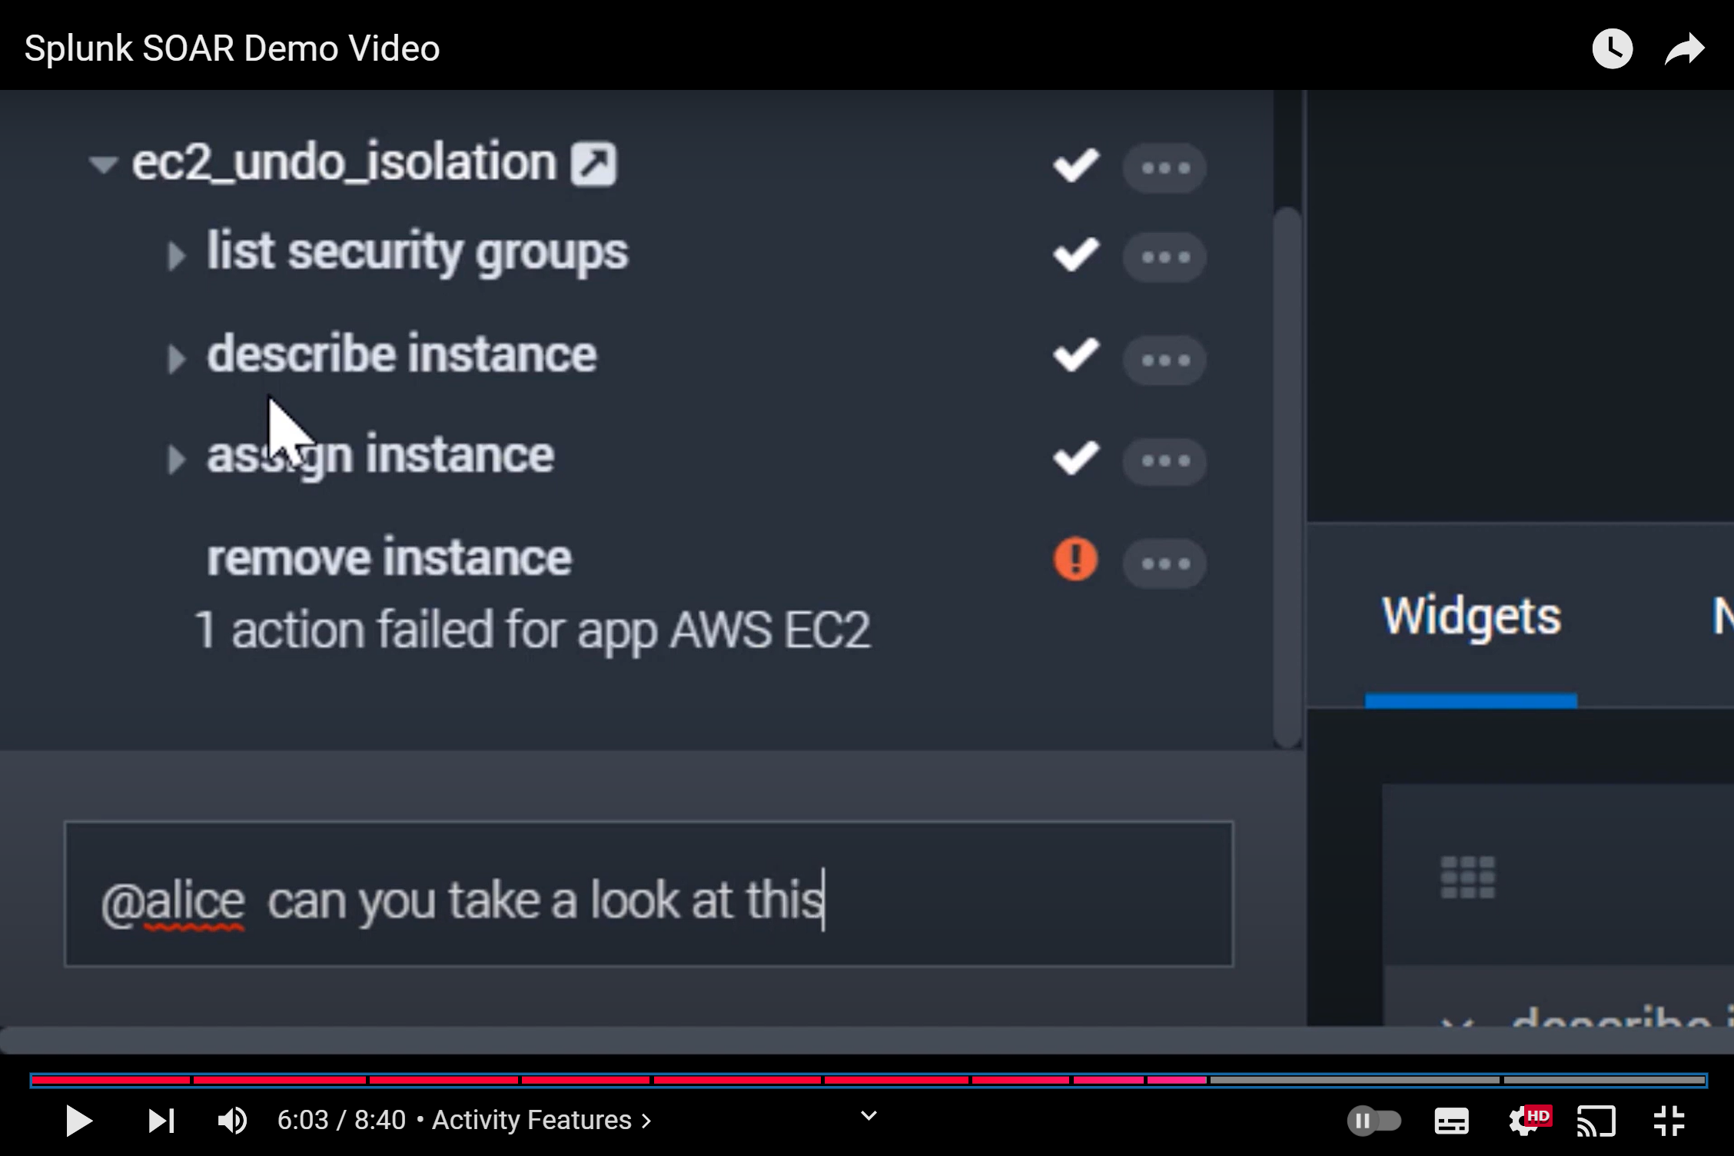

*(Splunk, 2021)*

Figure 1.21

Figure 1.21 above shows an example of Splunk’s collaboration prompt between multiple analysts. In this example, the analyst is tagging another analyst Alice, this feature highlights the collaborative functionality of Splunk SOAR, allowing analysts to discuss and delegate tasks in real time.

**Splunk’s Strengths**

Combined platform for SIEM and SOAR

Splunk offers a unified platform for security and observability, combining its SIEM (Splunk Enterprise Security) and SOAR (Splunk SOAR) capabilities under one interface. This integration allows organizations to monitor and investigate security incidents and IT operational issues seamlessly, providing a holistic view of their infrastructure.

Advanced Data Analytics and Machine Learning

Splunk utilizes advanced data analytics and machine learning through features like AI-driven anomaly detection, predictive analytics, and correlation capabilities to proactively identify threats. Splunk's machine learning capabilities, available via the Splunk Machine Learning Toolkit, enable real-time detection of sophisticated threats with less manual intervention, while features like adaptive thresholding dynamically adjust baselines for alerting, significantly reducing noise.

Scalability and Data Handling

Splunk's scalability and ability to handle massive amounts of both structured and unstructured data make it an ideal solution for enterprises of any size. Many other SIEM solutions struggle with unstructured data, but Splunk excels at providing complete visibility in modern environments.

Extensive Integrations

Splunk offers over 300 apps and add-ons through Splunkbase, ensuring extensive integrations with tools like AWS, Microsoft Azure, Google Cloud, and Kubernetes. Unlike competitors that require custom development for integrations, Splunk’s out-of-the-box compatibility ensures quicker deployment and fewer bottlenecks.

SOAR Playbook Automation

The platform's SOAR capabilities stand out due to its ability to automate repetitive security operations tasks through playbooks, which drastically improve incident response times. The drag-and-drop playbook editor simplifies creating automated workflows, even for users without extensive coding skills, as elaborated in figure 1.18.

Collaboration and Teamwork

Splunk also includes collaboration features, such as real-time comments, tagging teammates, and detailed incident timelines, as shown in figure 1.20. This enhances teamwork and minimizes the need for external tools. Integrations with platforms like MSTeams further improve communication.

Flexible Deployment Options

Splunk's deployment flexibility, supporting on-premises, cloud-based, and hybrid models, caters to various infrastructure and compliance requirements. This flexibility outpaces competitors like IBM QRadar, which focuses on on-premises deployments, or Microsoft Sentinel, which is primarily cloud-based. Splunk provides unparalleled flexibility.

User-Friendly Interface and Visualizations

Splunk's user-friendly interface provides highly customizable dashboards and visualizations that offer actionable insights into threats and system health. Features like visual search make querying data accessible to both security analysts and business stakeholders, allowing complex data to be broken down into simple bite-sized visualizations and graphs

Real-Time Threat Detection

Splunk’s real-time threat detection capabilities, enabled by a data streaming and indexing engine, process logs faster than many competitors, ensuring minimal delay in identifying and responding to threats.

Community and Support

Splunk has a robust community of users and developers, alongside extensive documentation, forums, and training resources, which sets it apart from competitors that lack such a strong support ecosystem.

**Splunk’s limitations**

Cost

One of the most commonly mentioned drawbacks is its cost. Splunk's pricing model is based on the volume of data ingested and retained, which can quickly escalate for organizations with large datasets or those requiring extensive data retention. This makes Splunk less appealing for smaller organizations or those with budget constraints. Many users also cite the need for additional licenses or modules to unlock specific features, further increasing the overall cost. According to Gartner, Splunk has a higher-than-average cost compared to other vendors, and organizations should evaluate the costs versus the security value of the data they plan to log.

Complexity

Another key challenge is Splunk’s steep learning curve, as mastering its Search Processing Language (SPL) and advanced features requires significant training and skilled personnel, which can be difficult for resource-constrained organizations.

Infrastructure demands

On-premises deployments require substantial hardware resources, which can conflict with efforts to minimize physical IT footprints. Deploying and configuring Splunk can also be complex and time-consuming. Fine-tuning the platform for optimal performance often requires substantial effort, especially for tailored environments. Gartner highlights that Splunk’s implementation often involves a higher-than-average number of professional service days, underscoring the need for adequate staffing or outsourcing to derive value from the tool.

Customer support

Lastly, Gartner notes that Splunk’s salesforce is primarily based in North America, potentially limiting sales support in other regions. Organizations outside North America may have to rely on value-added resellers, which could impact the quality or immediacy of support.

**Deployment Plan**

We will be utilizing Splunk Cloud for its scalability, flexibility, and ability to reduce on-premises resource dependencies. We will also be Implementing Splunk SOAR alongside Splunk SIEM for streamlined automation of incident response workflows.

Integration

We will connect all network segments (IT Department, Internal Network, Production Network, and Public Network/DMZ) to Splunk Cloud using forwarders or API integrations. We will need to enable Splunk SOAR to automate playbooks for high-priority security events such as malware detection, unauthorized access, or DDoS attacks.

Endpoint coverage

We will be deploying Universal Forwarders on:

* Domain Controllers (Both primary and secondary)
* Patch Management Server, VPN Server, and client devices (Windows 10/11)
* Public-facing servers (email server, external web server, file server, DNS server)
* Printers in the production network for monitoring print logs

Alerting and Playbooks

We will configure real-time alerts within Splunk SIEM for high-severity incidents like data exfiltration or server compromises. We will leverage Splunk SOAR playbooks to automate:

* Phishing email triage
* Crowdstrike malware triage
* User account lockout in case of brute-force detection
* Threat intelligence lookups and automated IOC (Indicator of Compromise) blocking

Rollout phases

We will have a 4-phase rollout plan to implement Splunk into our infrastructure

* Phase 1: Pilot in the IT Department and public network (DMZ)

We will install and configure Splunk forwarders on critical systems (e.g., Domain Controller, VPN Server, and DMZ servers). We wil then test the logging pipeline to ensure data is ingested into Splunk Cloud.

Next, will validate the effectiveness of automated SOAR playbooks on pilot data.

* Phase 2: Extend to the internal network

Next, we will add Universal Forwarders to internal clients, the Internal Web Server, and secondary Domain Controller. Then, we will enhance monitoring for lateral movement and unauthorized access patterns.

* Phase 3: Full rollout to production network

Now we will integrate printers and devices within the production network to monitor potential misuse.

Then we will configure and set up alerts for anomalies in printer usage or network activity.

* Phase 4: Optimizing and scaling

Lastly, we will fine-tune Splunk dashboards, alerts, and SOAR playbooks for operational efficiency. We will also scale the Splunk Cloud environment as needed based on log volume and future endpoint growth.

**Conclusion**

In conclusion, our team chose Splunk as the preferred SIEM tool because of its comprehensive capabilities in real-time data analysis, scalability, and advanced threat detection, as well as its powerful SOAR) feature. Splunk’s seamless integration with diverse systems within Vortex’s infrastructure ensures centralized log management and streamlined incident response. Its SOAR capabilities automate repetitive tasks, orchestrate workflows across security tools, and enable faster, more efficient responses to incidents, minimizing human error. Combined with Splunk’s analytics and machine learning, this enhances threat detection, mitigation, and response. Splunk Cloud's scalability also provides a flexible and future-proof solution, ensuring Vortex remains secure while meeting its evolving security and operational needs.

# IBM QRadar

Design Principles

IBM QRadar is built with scalability and ease of use as core design principles. It collects log data from an enterprise, its network devices, host assets and os (Operation System), applications, vulnerabilities, and user activities and behaviours.

* Scalability: IBM QRadar supports small to large-scale deployments, including dynamic scaling for increased log volume or expanded endpoint coverage. The distributed architecture also allows the addition of more event collectors and processors as needed.
* Integration: Provides over 450 pre-built integrations with technologies like Microsoft 365, AWS, Palo Alto Networks, and Cisco, which ensures smooth operation in diverse IT ecosystems. It also supports custom integration. QRadar allows you to create a custom parser for your data source. You can also collect events from various REST APIs for less common data sources.
* Extensibility: IBM’s application framework enables organisations to enhance QRadar’s functionality by adding apps from the IBM security app exchange. Some of the organisations participating in the IBM security app exchange includes AWS, Cisco, CrowdStrike, and Proofpoint. These apps help with threat hunting, machine learning analytics, and compliance management.

Architecture/ Framework

IBM QRadar’s architecture is designed for efficiency and adaptability. Key components include:

* Gather raw log data from endpoints, devices, and cloud services. Distributed collectors reduce the risk of data loss and provide fault tolerance.
* Handle normalisation, parsing, and correlation of log data in real-time. Utilises IBM’s sense analytics engine to identify threats and anomalies.
* A centralized web-based management interface. Provides user-friendly dashboards, reporting tools, and administrative controls.
* Collect network flow data (NetFlow, sFlow) to provide visibility into network traffic patterns.

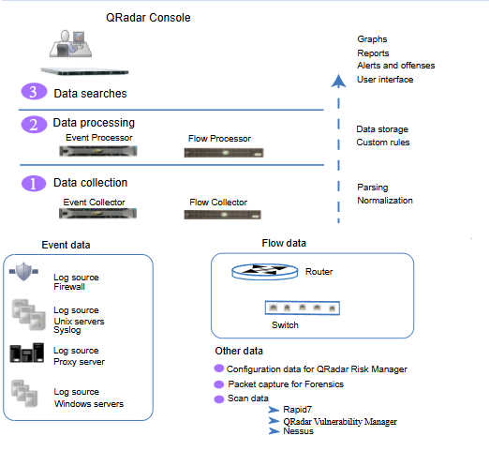

Figure 2.1. QRadar Architecture

The QRadar architecture can function the same way no matter the size or number of components in a deployment. The three layers that are in the diagram represent the core functionality of any QRadar system.

**Data collection:**

In the first layer is data collection (refer to figure 1), where data such as flows or events are collected from the network. The All-in-One appliance in QRadar can directly collect data from your network or use specific collectors like QRadar Event Collectors or QRadar QFlow Collectors to gather event and flow data. Once the raw data is collected, it is parsed and normalized to make it structured and easier to work with.

QRadar’s main focus is on collecting and analyzing two types of data: event data and flow data.

* Event data captures activities happening in the network environment at a given time. Examples includes user logins, VPN connections, email activity, firewall denials, and proxy usage.
* Flow data provides information about network sessions between two hosts, such as IP addresses, ports, byte counts, and packet data. This data is normalised into flow records, which represent these sessions. Additionally, full packet capture is available with the QRadar Incident Forensics feature for deeper analysis.

**Data Processing**

After data collection, the data moves into the processing layer. Here, the Custom Rules Engine (CRE) analyses event and flow data, generating alerts and offenses based on predefined rules. Once processed, the data is written to storage for future use.

An All-in-One appliance can handle event and flow processing without requiring additional components like Event Processors or Flow Processors. However, if your data volume exceeds the appliance's capacity, you can scale up by adding these processors or storage-focused appliances like Data Nodes to meet the requirements.

QRadar also offers additional features:

* QRadar Risk Manager (QRM) collects configuration data from your network infrastructure and creates a network topology map. It allows users to simulate changes to network configurations and assess potential risks.
* QRadar Vulnerability Manager (QVM) scans the network for vulnerabilities or integrates data from tools like Nessus and Rapid7 to identify security risks.
* QRadar Incident Forensics helps with in-depth forensic investigations and can replay full network sessions for detailed analysis.

**Data Searches**

Once data is collected and processed, it becomes accessible in the third layer for searches, analysis, reporting, and investigating alerts or offenses. The QRadar Console serves as the main user interface for managing these tasks.

In a standalone All-in-One system, all data collection, processing, and storage happen on the same appliance. In distributed setups, event and flow processing, along with data storage, are handled by separate components, while the QRadar Console is dedicated to searches, reporting, and investigations.

**Scalability with QRadar Components**

QRadar supports scalable deployments to manage data collection and processing in distributed networks. The system can handle varying loads depending on configuration, system capacity, and the type of data being processed. IBM certifies appliances for specific maximum event-per-second (EPS) rates, ensuring that they can meet performance needs for different use cases.

In essence, QRadar’s core strength lies in monitoring network security through efficient management of events and flows, making it a robust SIEM solution.

4o

**Resource requirements:**

To handle logs from 200 endpoints, we recommend deploying:

* Two Event Collectors: With each capable of managing up to 15,000 EPS (depending on the model), two collectors will comfortably manage an estimated log volume of 500–5,000 EPS (events per second) from endpoints, network devices, and applications.

Additional requirements include:

* 16 cores, 64 GB RAM, and 2 TB storage: Ensures smooth operation for medium-sized deployments like Vortex’s.
* High IOPS disk storage: Optimizes performance during peak event-processing times.
* Sufficient network bandwidth is crucial for real-time log collection. For 200 endpoints, a dedicated bandwidth of at least 1 Gbps is recommended to handle log transfers without bottlenecks.

System requirements:

To ensure that IBM QRadar works correctly, you must use virtual appliances that meet the minimum requirements. QRadar virtual appliances x86 hardware.

Memory requirements

The following figure 2.2 describes the memory requirements for virtual appliances.

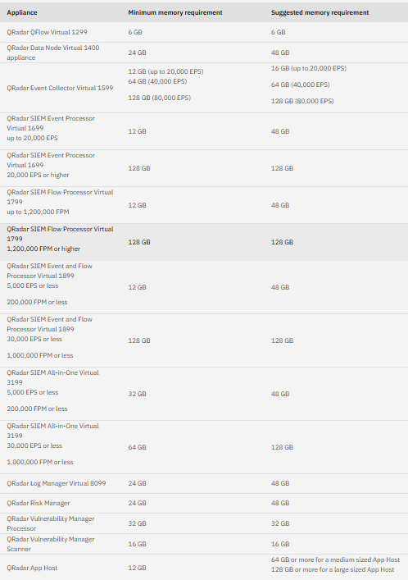

Figure 2.2 Minimum and suggested memory requirements for QRadar virtual appliances

Deployment options:

* On-Premises: Ideal for organizations with sensitive data or strict compliance requirements.
* Cloud-Based: Reduces infrastructure management burden and offers flexible scaling.
* Hybrid: Combines on-premises and cloud benefits for environments with mixed workloads.

**Cloud-Based deployment**

Many businesses are transforming to use the cloud on multiple platforms at the same time. Threats are evolving to attack data from every angle which leads to many cloud security challenges. IBM QRadar Cloud Visibility is a multi-cloud solution to manage and provide security for Amazon Web Services, Microsoft Azure, and IBM Cloud environments.

The Cloud Visibility app uses QRadar's existing integrations with cloud platforms to ingest log data from Infrastructure as a Service (IaaS) environment. It utilizes security rules provided by QRadar's cloud content extensions which is available through the IBM Security App Exchange. By analysing these data streams and applying pre-defined use cases, QRadar can detect common cloud misconfigurations, such as issues in AWS S3 buckets or Azure Blob storage and identify potential threats. The app enhances analysts ability to monitor and respond to potential offenses across AWS, Microsoft Azure, and IBM Cloud by providing clear visualizations.

Key enhanced capabilities for AWS include:

Streamlined log source management.

Detailed Identity and Access Management (IAM) insights for accounts, users, and roles.

Automatic population of QRadar's network hierarchy with cloud resources.

Comprehensive visualization of Amazon VPC flow logs.

**Data storage and event searching:**

* Uses indexed or compressed storage to optimize query performance and reduce disk usage.
* Advanced search capabilities with Advanced Query Language (AQL) for customized searches.

Main functionalities

IBM QRadar is extremely good in multiple core functionalities:

* Log Management: Collects logs from over 450 pre-integrated data sources and custom sources. Automatically parses and normalizes data to a consistent format.
* Threat Detection: Employs correlation rules, anomaly detection, and threat intelligence from IBM X-Force to identify known and unknown threats.
* User Behavior Analytics (UBA): Detects insider threats by analysing deviations in user activities (e.g., unusual login locations, unusual or weird file access patterns).
* Dashboards and Visualization: Visualizations of threat activity, compliance status, and overall system health.

Supported data sources:

* Security devices (firewalls, IDS/IPS).
* Operating systems (Windows, Linux).
* Cloud services (AWS, Azure, GCP).
* Application logs (databases, web servers).

Additional but useful features:

* Real-Time Monitoring: Provides live monitoring with instant alerting for critical events.
* Event Correlation: Supports complex rule creation for multi-step attack detection.
* Machine Learning: Leverages AI to improve anomaly detection and reduce false positives.

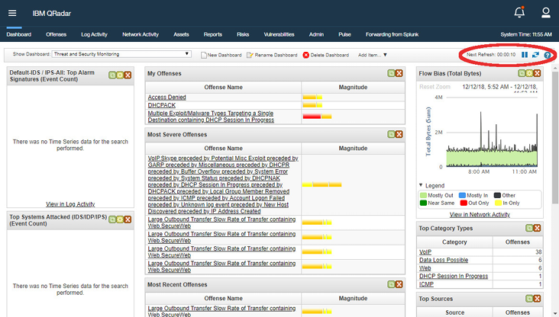

Figure 2.3 Dashboard

The Dashboard tab automatically refreshes every 60 seconds. The timer indicates the amount of time that remains until the tab is automatically refreshed. See Figure 2.2 for an example.

Log Activity and Network Activity tabs

The Log Activity and Network Activity tabs automatically refresh every 60 seconds if you are viewing the tab in Last Interval (auto refresh) mode. When you view the Log Activity or Network Activity tab in Real Time (streaming) or Last Minute (auto refresh) mode, you can use the Pause icon to pause the current display.

Offenses tab

The Offenses tab must be refreshed manually. The timer indicates the amount of time since the data was last refreshed. The timer flashes red when the timer is paused.

Offense investigations

IBM QRadar uses rules to monitor events and flows in your network to detect security threats. When the events and flows meets the criteria set in the rules, an offense is created to show that an attack or breach is suspected.

The offense summary window helps analysts begin their offense investigation. Refer to figure 2.3 for an example.

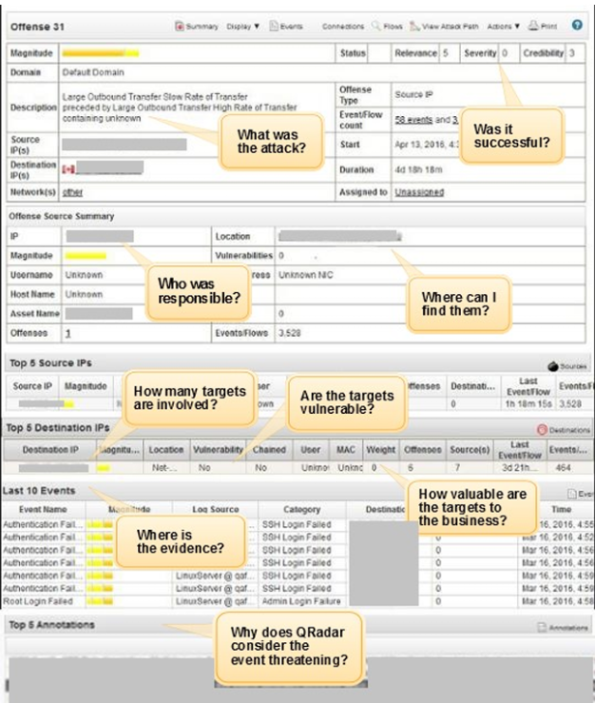

Figure 2.4 Offense Summary view

Strengths/ Advantages

IBM QRadar offers several competitive advantages and they include:

* Comprehensive Visibility: Unifies data from diverse sources into a single page for more efficient monitoring.
* Threat Intelligence: Integrates with IBM X-Force to provide up-to-date global threat intelligence, enhancing detection accuracy.
* Automation: Supports integration with IBM Resilient and other SOAR platforms for automated incident response.
* Compliance Management: Pre-configured templates for regulatory frameworks like PCI DSS, GDPR, and HIPAA simplify compliance reporting.

Limitations/ Weaknesses

Despite its strengths, there are definitely areas for improvement such as:

* Cost: Licensing, resource requirements, and professional services costs may be harder for smaller organisations to afford.
* Complex Rule Management: Creating and maintaining rules can become complex without proper training.
* Initial Setup: Requires skilled personnel for deployment and fine-tuning to fit organizational needs which will also add into additional costs.

Proposed implementation and deployment Plan

Infrastructure requirements:

* Two Event Collectors to handle logs from 200 endpoints. It is important to note that QRadar appliances are certified based on event per second (EPS) capacity. So, for 200 endpoints, typical EPS may range from 500 to 5000 EPS, depending on the type of devices and configured level of detail recorded in a log. A single event collector can usually handle up to 15000 EPS (depending on the model). If both the event collectors have similar capacity, two should be able to comfortably manage the logs from 200 endpoints.
* Establish centralized event processing and console management for streamlined operations.
* Utilize cloud-based storage for redundancy and long-term retention, ensuring compliance and disaster recovery readiness.

Deployment Strategy:

* Phase 1: Integrate QRadar with critical systems like firewalls, servers, and endpoint protection tools to immediately detect ransomware and unauthorized access attempts.
* Phase 2: Configure QRadar to monitor USB device activity across client and internal environments, adding custom parsers for specific USB-related logs if necessary.
* Phase 3: Fine-tune correlation rules to identify patterns such as multiple USB insertions, malicious file transfers, or unusual file activity.

Manpower Allocation:

* Assign a system administrator for maintaining QRadar appliances and managing upgrades.
* Deploy a security analyst team on a shift rotation plan to ensure 24/7 monitoring and rapid response to alerts.
* Conduct training sessions to upskill the team on managing QRadar, including creating and optimizing correlation rules.

Relevance to Vortex’s challenges

IBM QRadar directly addresses Vortex’s challenges by providing:

1. USB monitoring: Through custom rule creation and forensic capabilities, QRadar can track, analyse, and alert on USB device activity, mitigating risks of malware spread.
2. Real-Time Threat Detection: With advanced correlation rules and integration with IBM X-Force Threat Intelligence, QRadar enhances the detection of ransomware and unauthorized access attempts.
3. Incident Management: The centralized console and integration with SOAR tools can streamline the creation of an incident management plan, reducing chaos and ensuring consistent responses to future breaches.

**Conclusion**

IBM QRadar can be an excellent SIEM solution for Vortex Pte Ltd, offering the scalability, integration, and advanced threat detection necessary to address the company’s vulnerabilities. With its robust architecture and a tailored deployment plan, QRadar will not only mitigate current risks but also for future threats.

# Microsoft Sentinel

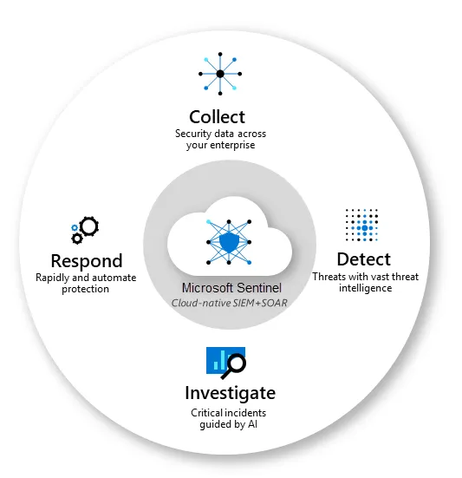

**Figure 3.1: Microsoft Sentinel**

**Design Principles**

Microsoft Sentinel is a cloud-native SIEM and SOAR solution designed for scalability, ease of use and seamless integration with cloud services.

* Scalability: Microsoft Sentinel cloud-native structure allows for easy scaling based on the needs of the organisation.
* Ease of use: Microsoft Sentinel is easy to set up and use as it’s designed with a user-friendly interface that will help with the setup process, and it also comes with pre-built templates, rules and analytics which can be easily configured to meet the needs.
* Seamless integration: Microsoft sentinel can integrate with different Microsoft products to allow data to be processed properly.

Microsoft Sentinel supports third-party integration using APIs and data connectors. Data connectors are used to integrate with Microsoft 365, Azure services and Microsoft defender to get data.

**Architecture/Framework**

Microsoft Sentinel key functional components include:

* Data Connectors: Data connectors will allow for Microsoft Sentinel to get data from different sources such as Amazon Web Services (AWS), Microsoft Azure, Common Event Format (CEF) and Trusted Automated eXchange of Indicator Information (TAXII).

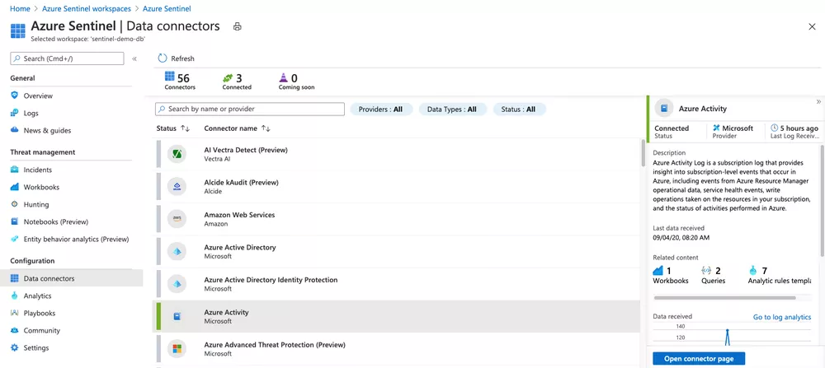

Figure 3.2: Data Connectors

* Workbooks: Microsoft Sentinel allows for workbooks to be integrated for monitoring, measuring and controlling of your data.

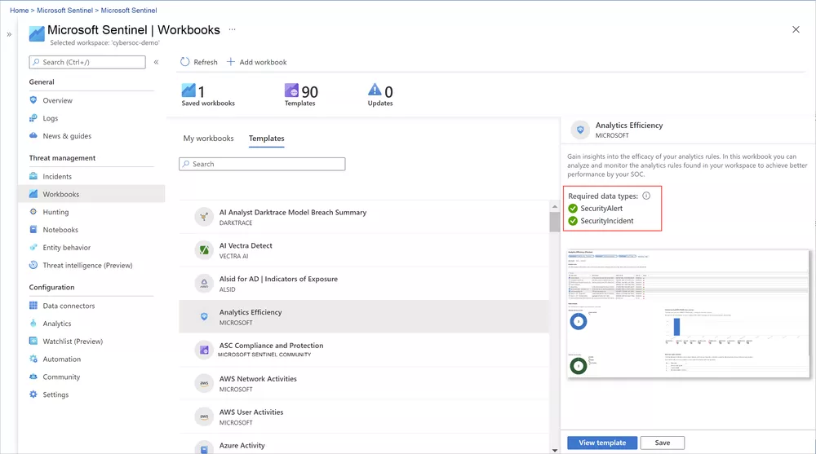

Figure 3.3: Workbooks

* Log Retention: Data is stored by Microsoft Sentinel utilising Log Workspaces, but it can also be sent to ADX for storage. To query in Microsoft Sentinel, you need to know Kusto Query Language (KQL).

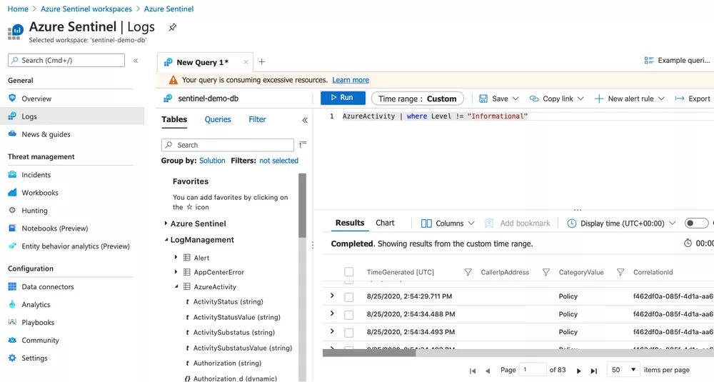

Figure 3.4: Logs

* Analytics Rules: Analytic rules or SIEM content is used to associate alerts into incidents. It can either be scheduled queries or queries that run on demand. A group of related alerts that forms a potential threat is known as an incident which allows for easier investigation and resolving several alerts at once.

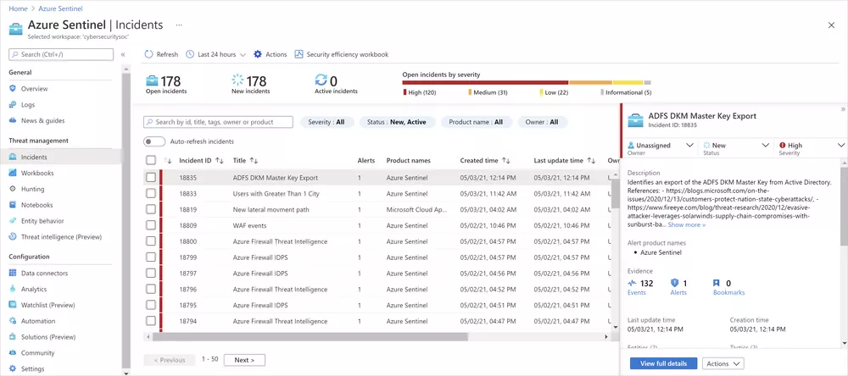

Figure 3.5: Incidents

* Threat Intelligence: Threat hunting can be expanded beyond the EDR capabilities by forwarding Microsoft 365 logs to Microsoft Sentinel. This involves identifying threats that have breached the existing controls by using specific detection content released by Microsoft or other intelligence. Analysts use zero trust, “assume breach” mindset to find threats that already existed. To use this feature:
  + Query: Microsoft Sentinel threat hunting identifies queries that can find valuable data for potential attacks.
  + Hunt: Microsoft Sentinel allows bookmarking to save events while hunting which can be returned to or shared to others. It also allows for combination of events into one incident for whole investigation.

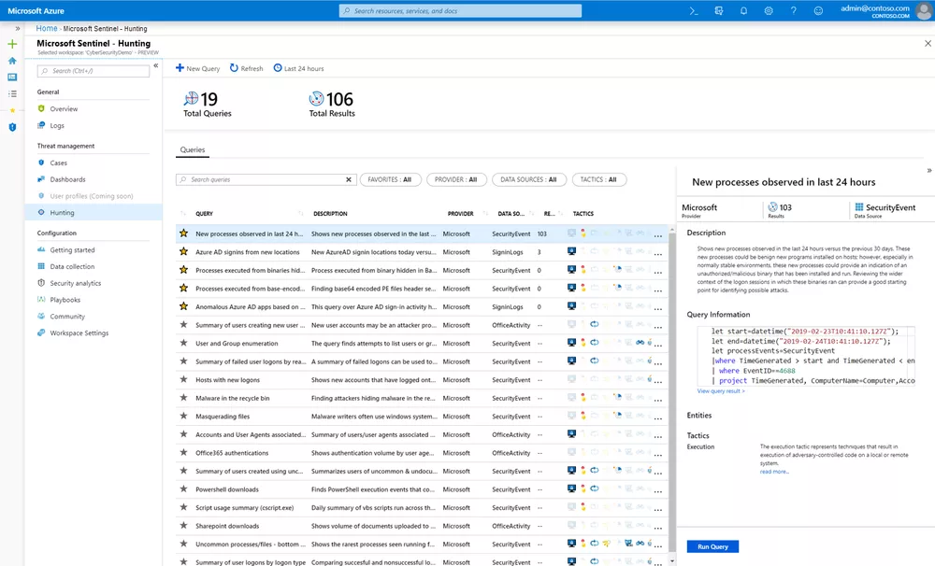

**Figure 3.6: Hunting**

* Incidents: An incident is created when an alert is triggered. The following capabilities can be used for incident investigation:
  + Assignment and incident status: Staus of incident can be altered or assigned to different people for investigation.
  + Investigation functionality: Sentinel visually investigates concurrent or multiple attacks by automatically mapping entities across incidents along a timeline.

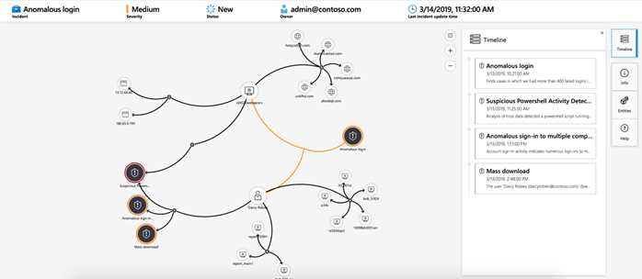

**Figure 3.7: Mapping**

* Playbooks: They are sequences that are automated using Azure logic apps to address security incidents. By automating tasks, it can allow for better focus on more important threats and incidents.

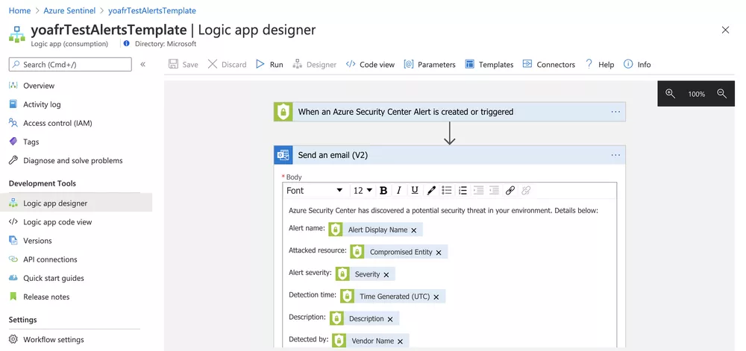

Figure 3.8: Logic Apps

**Resource Requirements:**

* A Microsoft Entra ID license and tenant, or an individual account with a valid payment method are required to access Azure and deploy resources.
* An Azure subscription to track resource creation and billing.
* A log Analytics workspace is required to house the data the Microsoft Sentinel ingests and analyzes for detection, analytics, and other features. It must not have a resource lock applied, and the workspace pricing tier must be pay-as-you-go or a commitment tier as legacy pricing tiers and resource locks aren't supported by Microsoft Sentinel.

**Cloud Deployment:** Microsoft Sentinel is a cloud-native platform therefore minimal hardware is required.

**Data Storage:** There are 2 kinds of ingested data, primary security data and secondary security data. Primary security data consists of critical value used for real-time monitoring and needs to be readily available. In contrast, secondary security data is supplemental data which does not need to be readily available.

There are 3 types of log storage plans, analytics logs plan, auxiliary logs plan and basic logs plan. Analytics logs plan is to store primary data to allow it to always have easy access at high performance. Auxiliary logs plan is to store secondary security data at a very low cost for long period of time while still allowing for limited accessibility. Basic log plan can be used as a substitute for auxiliary log while it remains in preview.

These plans can preserve data in 2 different states, the interactive retention state and the long-term retention state. The interactive retention state is when the data is just ingested, and the long-term retention state is to preserve older data in its original form for up to 12 years at an extremely low cost.

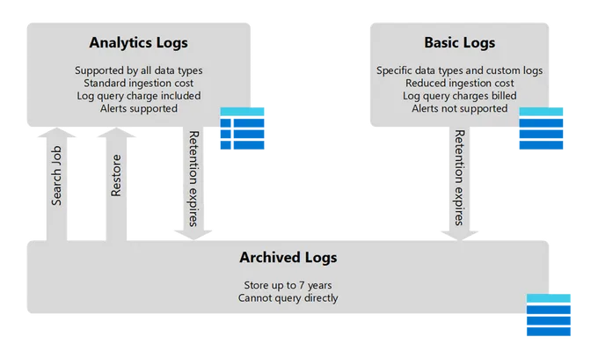

**Figure 3.9: Logs**

**Main Functionalities**

* Core Functionalities
  + Collect data at cloud scale: Data collection across all users, devices, apps and infrastructure in multiple clouds using built-in data connectors.
  + Stay ahead of cyber threats: We can learn more about contextual and behavioral information for cyberthreat hunting, investigation and response using built-in entity behavioral and machine learning.
  + Streamline investigation with incident insights: Allow for easy viewing of the full scope of a cyberattack, investigate related alerts, and search historical data.
  + Accelerate response and save time by automating common tasks: Sort incidents faster using automation rules and automating workflows using the built-in playbook.
* Dashboard shows the incident data, automation data, status of data record, data collectors, threat intelligence, analytics data.
* Data sources include Microsoft Services such as Microsoft 365, Microsoft Azure AD, Microsoft Defender, Standard Protocols such as Syslog and Common Event Format (CEF) for non- Microsoft sources and Third-Party Integrations such as Cisco and AWS.
* Additional features include SOAR (Security Orchestration, Automation and Response) which is a multiple software programs that allows an enterprise to get data about cyber threats and respond to it automatically with little to no human assistance. Figure 3.10 below shows the connection between SIEM and SOAR.

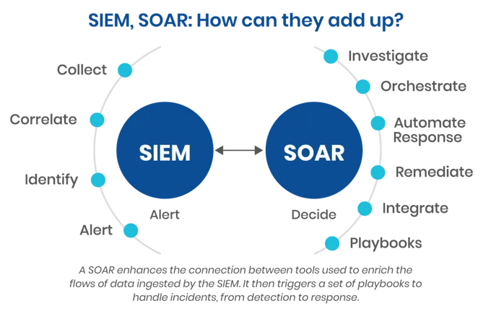

Figure 3.10: SOAR & SIEM

**Strengths/Advantages**

* Easy Intergration with Azure services: Microsoft Sentinel allows for Azure Services to be integrated easily.
* Fully Cloud Native architecture: Microsoft Sentinel is built-on cloud-native architecture which allows for easy scalability.
* Centralized monitoring: Microsoft Sentinel allows users to see all information regarding the company at one time.
* Automated Incident Response: Microsoft Sentinel uses playbooks to response to threats automatically.
* High Customisability: Microsoft Sentinel allows for different customisation such as data connectors to get data from different sources, custom analytics rules to find abnormalities in the system, custom playbooks for incident management to have different automated responses for different incidents.
* Real-time advanced threat detection: By using near Real Time (NRT) analytics rules, Microsoft Sentinel allows for real-time threat detection.

**Limitations/Weakness**

* Dependency on Microsoft software and cloud: It is very dependent on Microsoft products and the management of third-party cloud services will be harder to manage.
* Cost considerations: The pricing plan is based on data going in and is measured in GB. If not managed properly, costs can increase easily.
* Difficulty in data ingestions and parsing logs: Microsoft Sentinel relies on third-party tools to get data from unsupported sources which can get complex and hard to maintain.
* False positives generation: Microsoft Sentinel needs to be tuned regularly to reduce the number of false positives, and this process is very time-consuming.

**Implementation and Deployment**

1. Access log sources to find out how many log files or data exist.
2. Find out what Microsoft products or third-party tools are needed.
3. Set up a Log Analytics Workspace in Azure.
4. Install connectors for gathering logs from endpoints, VPN, cloud environments, and USB device activity.
5. Create analytics rules for detecting ransomware, malware, and unauthorised access.
6. Setup playbooks for automating quarantine of infected devices or alerts for suspicious activities.
7. Train CSIRT and IT staff in KQL and Microsoft Sentinel’s features to be up to date.
8. Review dashboards and find-tune analytics rules regularly to stay updated.

**Conclusion**

Because of its cloud-native architecture, seamless connection with Microsoft services, and threat-detection capabilities, Microsoft Sentinel is a great fit for Vortex Solutions. Vortex Solutions which is already handling sensitive data and remote operations, Microsoft Sentinel provides scalability and cost-effectiveness. The solution offers tools to automate incident responses and fixes the company's existing vulnerabilities.

# FortiSIEM

**Design Principles**

Designed with monitoring and analytics in mind, FortiSIEM can be used for a multitude of different applications in an enterprise.

* Scalability: FortiSIEM with ClickHouse can process a high number of events per second without needing a large number of nodes/shards. This allows organisations to design the solution with the planned maximum number of events per second throughout the use period of the solution in mind while staying cost-efficient.
* Integration: FortiSIEM supports a wide range of third-party softwares from many different vendors such as Cisco, Amazon and Microsoft, to be integrated to assist with discovery, performance monitoring and log analysis.
* Resilience: ClickHouse replicas which are backups of the data in a shard stored in additional hosts can be put into a shard. In the case that a host stops working, the system will switch over to the next replica to use instead, this will protect against the loss of data when a node malfunctions.

**Architecture**

FortiSIEM is designed for flexibility, scalability and has a multitude of features. Key Functions include:

* Combined Security Operations Center (SOC) and Network Operations Center (NOC) analytics with integrated Configuration Management Database (CMDB).
* Highly scalable architecture
* Unified, simple interface
* Integrated User Entity and Behaviour Analytics (UEBA) engine
* Simple analytics interface
* Extensive and customisable reporting, including hundreds of inbuilt compliance reports
* Threat intelligence, including commercial, open source and FortiGuard

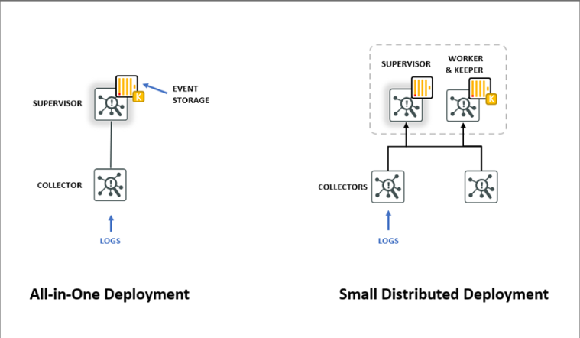**Figure 4.1**

The above figure shows two methods for deployment fit for small and medium sized businesses.

FortiSIEM has a deployment method called the all-in-one architecture that is a self-contained single server solution fit for smaller organisations. Using this method, the FortiSIEM supervisor node is the only one needed to be deployed. The node operates the GUI, FortiSIEM application and the ClickHouse database using only one shard without the need for any replicas, as well as the ClickHouse keeper processes.

However, organisations that are looking to upgrade their solutions in the future will want to consider using the small, distributed deployment that consists of a supervisor as well as a worker node. The presence of a second node has its merits by making the system remarkably more scalable while also providing an extra layer of durability by having the worker node host a second replica.

Collector nodes can fit into either method of deployment to facilitate remote site log collection, offload log collection and performance monitoring from the supervisor, as well as agent log collection. A minimum of one collector node should be deployed in every architecture to help with log collection and the support of FortiSIEM server agents.

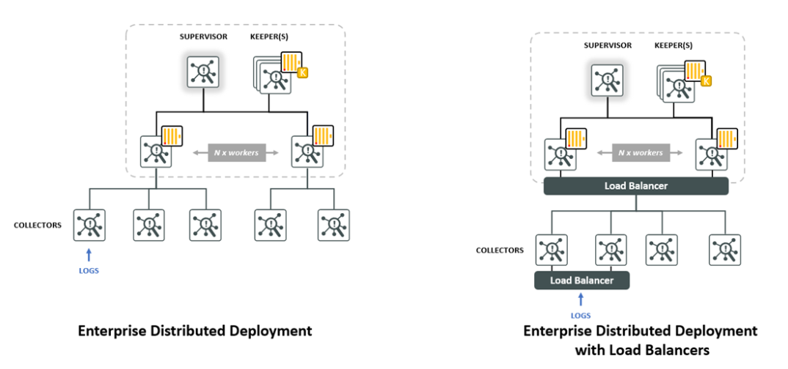**Figure 4.2**

The above figure shows deployment methods fit for larger enterprises.

Deployments in enterprises range from a couple hundred to thousands of devices accompanied by a huge number of events per second (EPS). Here is where FortiSIEM with ClickHouse has the upper hand compared to other solutions due to its capability to manage huge numbers of EPS using relatively few nodes.

An enterprise deployment consists of a supervisor node, an appropriate number of worker nodes to support the required number of shards and replicas, one or three dedicated keeper nodes, and collectors.

Both supervisor and worker nodes can be deployed as either virtual or hardware appliances. If virtual appliances are used, they should be deployed onto a scalable, enterprise class hypervisor platform, and dedicated resources that meet the minimum requirements should also be given to virtual appliances. Should a supervisor node be deployed as hardware, organisations should select a large hardware appliance for it.

Extra storage can be added to the system even after the system is already deployed by expanding the ClickHouse disk on the nodes in the shards. FortiSIEM eventDB is also supported to facilitate archival into NFS servers for long term storage, but archiving data into an NFS server does come with its drawbacks as querying and data retention can be made easier by allocating more storage to ClickHouse.

Organisations should choose to deploy either one or three keeper nodes adhering to their budget and requirements as dedicated keeper nodes serve as resilience in the system.

If only one keeper node is used, when it fails, the system will enter read only mode. If a cluster of three keeper nodes are used, the system will be resilient to the failure of one keeper node, however if two out of three of the keeper nodes fail the system will lose quorum and enter read only mode.

Organisations can choose whether to use a load balancer in their system to diffuse the connections between the collector nodes and worker nodes, load balancers also distribute inbound syslog or FortiSIEM server agent traffic between collector nodes.

**Cloud deployment**

FortiSIEM has a flexible deployment model that can be deployed on cloud and hybrid cloud environments using virtual appliance images that can be deployed on cloud hypervisor environments such as AWS and Azure.

Cloud based deployments can join with hardware appliances to create hybrid cloud architectures so that the organisation will have both cloud based and local log sources.

**Main Functionalities**

**Core Functionalities:**

* Log ingestion and storage
* SOC Analytics and incident response
* Performance monitoring
* Compliance reporting
* Management reporting

**Dashboard**

FortiSIEM features four different types of dashboards to assist in understanding collected data.

* Summary Dashboard: The summary dashboard shows the metrics of every device including incidents, up-time and health in a simple to understand spreadsheet with colour coding to highlight certain values that should be investigated. This type of dashboard is best for collecting information about the infrastructure components in a short amount of time by allowing the user to see all the metrics and be able to group certain types of devices together in a cohesive fashion.
* Widget Dashboard: The widget dashboard features a wide variety of charts that can be set to show certain types of information. Three main advantages of using the widget dashboard are colour coding, dynamic search and streaming computation. Colour coding can help users to quickly spot issues that arises, dynamic search allows the user to filter by hostname or IP addresses to quickly obtain information needed and streaming computation means that information is being relayed to the charts in a streaming mode that does not need to make multiple queries to the database allowing for faster load speeds.
* Business Service Dashboard: The business service dashboard is straightforward and shows information about the business service health, it also allows the user to see what incidents are related to which business services and what devices are affected by the incident.
* Identity and Location Dashboard: The identity and location dashboard shows the IP addresses of every user along with the user’s name and their location.

**Data sources**

Supported data sources include:

* Perimeter firewall, UTM appliances, IPS and proxy
* DNS and DHCP servers
* Active Directory and AAA servers
* Antivirus management centers
* Vulnerability scanners
* Vulnerable assets, such as web servers
* High value assets, such as servers that contain HR and accounting data
* PCI-DSS networks or other high security, compliance related logging requirements

**Strengths/Advantages**

* Real-time monitoring: FortiSIEM has built in reports and alerts that will scan the network for events and potential threats.
* Features: FortiSIEM has a wide range of features which can eliminate the requirement of many other products.
* Flexibility: Custom parser development is one of the features of FortiSIEM that can be used for unsupported devices.
* Event Clustering: FortiSIEM boasts event correlation and threat hunting competencies, resulting in enhanced security response and monitoring.

**Weaknesses/Limitations**

* Time-consuming: Although FortiSIEM’s custom parsing is flexible, it takes a large amount of time and effort to create parsers to integrate unsupported devices.
* Slow response: FortiSIEM users have brought up that the speed of FortiSIEM patch updates and technical support are not satisfactory.
* Reporting and query: Compared to competitors such as Splunk, FortiSIEM is lacking in reporting and query efficiency.
* Cost: FortiSIEM licensing model are considered pricier especially when integrating other solutions.

**Implementation and Deployment**

**Requirements**

* Deployment: The small, distributed deployment method is the most suitable one for Vortex as it is scalable and more resilient compared to the all-in-one deployment.
* Resource: One supervisor node, one worker node and two collector nodes will be sufficient for Vortex. The worker node can host the second replica in the system so in the case that the supervisor node experiences failure, the worker node can act as the backup to ensure the system stays running.

**Deployment**

1. Set up FortiSIEM and integrate needed third party products.
2. Configure FortiGuard to detect suspicious activity.
3. Configure connections for endpoints devices to facilitate log collection.
4. Configure security rules to lock user accounts and send an alert if multiple failed login attempts are made in a short period.
5. Configure monitoring of file activity to detect malware that could have been introduced from infected USB flash drives.
6. Configure Dashboards to group devices with similar functions together and to set alert values for device metrics to facilitate easier monitoring.

**Considerations**

* Some devices may be unsupported by FortiSIEM and will require creation of parsers to integrate them.
* Licensing model may be pricey due to having to integrate other solutions

**Conclusion**

FortiSIEM should be considered by Vortex as the deployment method offers scalability and can manage large amounts of events per second with ClickHouse. FortiSIEM can also address security concerns with its threat intelligence and integration with FortiGuard.

# Our chosen SIEM product

Our team chose Splunk as the preferred SIEM tool due to its industry-leading capabilities in log management, real-time threat detection, and advanced analytics. Splunk offers unparalleled scalability, making it suitable for handling the diverse and growing infrastructure of Vortex Pte Ltd. Its seamless integration with Splunk SOAR enables automation of incident response workflows, reducing response times and improving operational efficiency. Furthermore, Splunk Cloud’s flexibility eliminates the need for extensive on-premises hardware, ensuring high availability and streamlined maintenance.

**Proposed Splunk architecture**

**Deployment Plan**

We will be using Splunk Cloud for its scalability, flexibility, and ability to reduce on-premises resource dependencies. We will also be Implementing Splunk SOAR alongside Splunk SIEM for streamlined automation of incident response workflows.

Integration

We will connect all network segments (IT Department, Internal Network, Production Network, and Public Network/DMZ) to Splunk Cloud using forwarders or API integrations. We will need to enable Splunk SOAR to automate playbooks for high-priority security events such as malware detection, unauthorized access, or DDoS attacks.

Endpoints coverage

We will be deploying Universal Forwarders on:

* Domain Controllers (Both primary and secondary)
* Patch Management Server, VPN Server, and client devices (Windows 10/11)
* Public-facing servers (email server, external web server, file server, DNS server)
* Printers in the production network for monitoring print logs

Alerting and playbooks

We will configure real-time alerts within Splunk SIEM for high-severity incidents like data exfiltration or server compromises. We will leverage Splunk SOAR playbooks to automate:

* Phishing email triage
* Crowdstrike malware triage
* User account lockout in case of brute-force detection
* Threat intelligence lookups and automated IOC (Indicator of Compromise) blocking

Implementation phases

We will have a 4-phase rollout plan to implement Splunk into our infrastructure

* Phase 1: Pilot in the IT Department and public network (DMZ)

We will install and configure Splunk forwarders on critical systems (e.g., Domain Controller, VPN Server, and DMZ servers). We wil then test the logging pipeline to ensure data is ingested into Splunk Cloud.

Next, will validate the effectiveness of automated SOAR playbooks on pilot data.

* Phase 2: Extend to the internal network

Next, we will add Universal Forwarders to internal clients, the Internal Web Server, and secondary Domain Controller. Then, we will enhance monitoring for lateral movement and unauthorized access patterns.

* Phase 3: Full rollout to production network

Now we will integrate printers and devices within the production network to monitor potential misuse.

Then we will configure and set up alerts for anomalies in printer usage or network activity.

* Phase 4: Optimizing and scaling

Next, we will fine-tune Splunk dashboards, alerts, and SOAR playbooks for operational efficiency. Lastly, we will have to scale the Splunk Cloud environment as needed based on log volume and future endpoint growth.

# Splunk Log Management

IT Department

For the IT Department, the key log sources include the Primary Domain Controller, Patch Management Server, VPN Server, and Windows Clients (10/11). From the Primary Domain Controller, logs related to authentication (e.g., Kerberos events), group policy changes, and account management activities will be collected. The Patch Management Server will provide logs on software patch deployment to identify failed updates or unusual activity. VPN Server logs will include VPN connections, user activity, IP allocations, and failed login attempts. Logs from Windows clients will capture endpoint logs, such as application activity, login/logout events, and Windows Defender alerts. The log collection mechanism involves deploying Splunk Universal Forwarders on each server and client machine. These forwarders will transmit logs to the Splunk Cloud environment over secure channels (e.g., TLS). Additionally, the Windows Event Log Monitor will extract logs from the Domain Controller, VPN Server, and clients.

Internal Network

For the Internal Network, important log sources include the Secondary Domain Controller, Internal Web Server, and Windows Clients. The Secondary Domain Controller will provide logs for replication errors, failed authentications, and policy updates. The Internal Web Server will provide application and server logs, including errors, suspicious input, and system performance metrics. Windows Clients will capture user activity logs, particularly for shared resources or sensitive files. Universal Forwarders will route logs to Splunk Cloud, and Splunk’s HTTP Event Collector (HEC) will capture application logs from the internal web server. The logs will be normalized using Splunk’s Common Information Model (CIM) to ensure consistent fields for analysis.

Public Network (DMZ)

For the Public Network (DMZ), critical log sources include the Email Server, External Web Server, File Server, and DNS Server. The Email Server will provide logs related to email delivery, spam filtering, and access patterns. The External Web Server will capture HTTP request/response logs, including errors and unusual patterns indicating possible attacks, such as SQL injection or XSS. The File Server will provide access logs for file downloads and unauthorized access attempts. The DNS Server will supply query logs to detect potential DNS tunneling or DDoS attacks. Logs from these sources will be collected using Universal Forwarders and forwarded to Splunk Cloud’s ingestion pipeline. DNS and email server logs will be configured to forward data in Syslog format directly to Splunk Cloud.

Production Network

For the Production Network, key log sources include the Secondary Domain Controller and Commercial Printers. The Secondary Domain Controller will provide logs for account management and network access controls. The Commercial Printers will provide printer activity logs to monitor large file transfers or unusual print jobs that may indicate insider threats. Universal Forwarders will be set up on the Domain Controller and printers (if supported). If native integration is not available, network monitoring tools will be used to capture printer logs.

Data Transmission and Indexing

All logs will be securely transmitted to Splunk Cloud using TLS encryption, ensuring data integrity and confidentiality. Splunk Cloud’s indexing capability will structure the data, making it searchable and enabling rapid query performance. The data will be categorized into indexes based on source types (e.g., "firewall_logs," "dns_logs") for better organization and access control. Figure 5.1 below shows an example usage of the Splunk Log Observer interface, which provides a comprehensive view of various system logs and events. The interface displays a timeline of log entries, organized by severity level, allowing users to quickly identify and analyze potential issues or anomalies within the system. The detailed log entries provide valuable information for troubleshooting and monitoring purposes.



*(Splunk, n.d.)*

Figure 5.1

Benefits of Using Splunk Cloud for Vortex

Splunk Cloud offers several benefits for Vortex Pte Ltd’s log collection strategy. Its scalability ensures that it can handle increasing log volumes as Vortex’s infrastructure expands. The centralized monitoring capability allows all logs from various network segments to be aggregated in one location, simplifying security operations. Real-time analysis is enabled by Splunk's advanced search capabilities and dashboards, which support rapid anomaly detection and alerting. Additionally, Splunk Cloud’s data retention policies align with industry regulations like ISO 27001 and GDPR, ensuring compliance.

**Indicators of Compromise (IOCs)**

**Abnormal USB activity:** Examples**:**

* File system changes: Execution of autorun files by USB insertion could indicate that there is a compromise.
* System settings changes: Malware from USB can modify system settings to maintain access after USB is removed.
* Suspicious activity: Infected computers can be under the control of a bot and be accessed during non-office hours, log-in activity monitored at an unusual time can be can indicator of compromise.

**Unusual VPN behaviour:** Examples:

* Geographical anomalies: If traffic is coming from IP addresses and geographical regions that are not connected to the user, it can indicate there is a compromise.
* Abnormal outbound traffic: Unusual level of traffic during a VPN session can indicate there is a compromise.

**Vulnerabilities**

**Malware via USB Devices:**

* It occurs when:
  + The attacker inserts a USB flash drive containing a malicious code to a computer without realising that the device holds the code.
  + The USB device is perceived for other items, which prevents the computer from detecting it and allowing the malware to be installed automatically.
* Examples:
  + Rubber Ducky which looks like a regular USB drive but imitates a keyboard which can execute malicious code.
  + BadUSB works the same as Rubber Ducky by using a fake USB drive to imitate a keyboard to execute malicious code.
  + The files inside the USB drive can be a malware like trojan virus that allows attackers to gain access into a users’ system with their software that users will be unable to detect.

**Weak VPN Configurations:**

A poorly configured VPN creates significant vulnerabilities, providing attackers with opportunities to breach the network.

It occurs when there is:

* Weak Authentication which is when VPN password is simple, easy to guess or when outdated authentication methods are used that are vulnerable to attacks.
* Absence of Multi Factor Authentication. Without MFA, attackers only need to compromise a single authentication factor, typically the password, to gain access to the network. MFA adds an extra layer of security by requiring users to provide additional verification.
* Poor encryption such as outdated or weak protocols (e.g., DES or MD5) that attackers can intercept, and decrypt sensitive data transmitted through the VPN.
* Vulnerable patches are not updated so it can be exploited.

**Rules to detect Compromise:**

* Have USB device control policies
  + Create rules to block unapproved USB devices from being connected to company systems
* Disable autorun
  + Ensure autorun is disabled through Group Policy settings or endpoint management solutions to prevent malware from auto-executing
* Have Antivirus installed on the computer
  + Deploy endpoint antivirus solutions with real-time monitoring and scanning of newly connected USB devices
* Ensure VPN password is complex
  + Configure systems to require strong passwords
* Regularly update VPN clients and servers
  + Regularly scan and apply patches to VPN servers and client software
* Use strong encryption protocols
* Monitor log activities
  + Monitor log-in activity and file activity to alert if attempts to log-in or access files are made during unusual times of the day
* Set password rules
  + Limit incorrect password attempts, lock account after three failed attempts within fifteen minutes
* Successful Login from Unusual Locations
  + Alert on successful logins from geographically distant or unusual locations. For example, if a user from the Singapore successfully logs in from a location in Russia within an hour, flag it as suspicious.
* Suspicious User Behaviour
  + Monitor for unusual user activity patterns, such as accessing files or resources they don’t typically interact with. Alert if a user accesses large amounts of sensitive data during off-hours or performs tasks outside their usual role.
* Unusual Privilege Escalation
  + Watch for privilege escalation actions, such as users suddenly gaining administrative privileges, flag if a user who doesn’t normally have admin privileges is added to an admin group.
* Uncommon Ports or Protocols
  + Monitor for the use of uncommon ports or protocols that are typically used by attackers for command and control (C2) communications, alert if traffic is detected on ports such as 4444 or 9999, which are commonly used by malware.
* Anomalous Network Traffic
  + Detect abnormal outbound traffic, such as large volumes of data being transferred from internal servers. Trigger an alert if there’s an unusual amount of data being sent to an external IP address or a foreign country.
* Execution of Suspicious Scripts or Files
  + Trigger an alert if a script with known malicious signatures (e.g., PowerShell, VBScript, XSS or SQLi scripts) is run by a non-administrative user.
* Malicious DNS Requests
  + Detect DNS requests to known malicious or suspicious domains, flag DNS queries to domains associated with malware or known malicious IP addresses.

**Incident Response Plan**

**Incident Response Team (IRT) Structure**

Incident Commander (VP, IT – Mr. Josh Tang):

* Oversees the entire incident response process
* Makes final decisions during critical incidents
* Liases with the CEO and other department VPs to communicate major incidents and their status

Technical Lead (Security / CSIRT Team):

* Leads the investigation of incidents
* Coordinates technical responses and forensic analysis
* Ensures proper containment, eradication, and recovery of affected systems

IT Support Lead (Managed Security Product and Services):

* Provides initial troubleshooting and immediate containment for lower- severity incidents
* Assist the CSIRT team during high and critical incidents by providing system knowledge and technical support

Applications and Infrastructure Lead (Applications and Infra Team):

* Handles issues involving application-level or infrastructure-level vulnerabilities
* Ensures the affected systems are patched or restored to normal functioning

Communication Coordinator (CFO – Mr. Jeffrey Ho):

* Manages external and internal communication regarding incident
* Coordinates with legal advisors and stakeholders regarding compliance and reporting requirements

Security Analysts (Security / CSIRT Team):

* Monitors systems for suspicious activity and investigates alerts
* Documents the incident timeline and analysis details for post-incident review

**Incident Classification and Categorisation**

* Low severity: Single endpoint affected but minimal operational impact
* Medium severity: Multiple endpoints affected and potential data compromise
* High severity: Ransomware outbreak, significant operational downtime
* Critical severity: Widespread attacks affecting clients and severe reputational damage

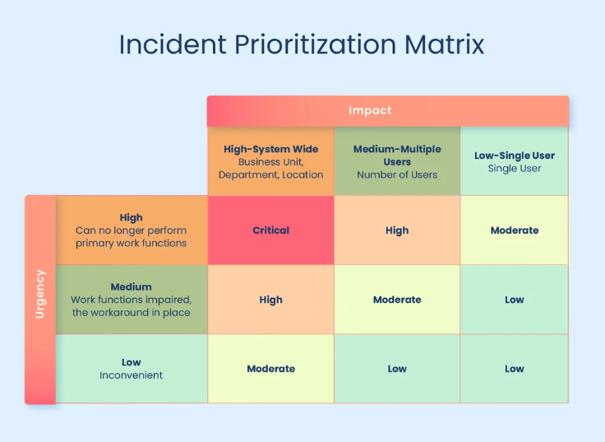

**Figure 5.1**

The table above (Figure 5.1) will help us to understand how to categorise the severity of the incidents. For example, an incident that has a high impact to the business, but low urgency can be considered as a moderate / medium severity incident. A low urgency but high impact incident can also be considered as a moderate / medium severity incident. It is important to categorise the severity of the incidents properly so that we will not waste additional time and resources.

**Differences between Urgency and Impact**

Urgency refers to how quickly an issue needs to be addressed to prevent further harm or escalation while Impact refers to the extent of the disruption caused by the incident to business operations, customers, or systems.

**Service Level Agreements**

* Detection and acknowledgement: All incidents must be acknowledged within 15 minutes of detection
* Containment: Contain the threat within 1 hour for high/ critical severity incidents
* Remediation: Resolve incidents within 12 hours for moderate severity and 24 hours for high severity
* Post-incident review: Conduct a post-incident review within 48 hours after resolving the incident

Table 1 – Service Level Guide Table

|  |  |  |  |  |  |
| --- | --- | --- | --- | --- | --- |
| **Severity Level** | **Description** | **Initial Response Time** | **Resolution/Workaround Time** | **Escalation Time** | **Examples** |
| Critical | A critical issue causing a complete business disruption or significant impact on multiple users or systems. | Within 15 minutes | Within 1 hour | Within 30 minutes | Ransomware attack that encrypts key business data (major business disruption and potential data loss). |
| High | Significant impact on key systems or operations; partial workarounds available. | Within 20 minutes | Within 2 hours | Within 2 hours | A key server goes down (affects business operations, but a temporary workaround exists). |
| Medium | An issue causing partial business disruption, impacting specific users or non-critical systems. | Within 30 minutes | Within 4 hours | Within 4 hours | A group of users can't access a shared folder (affects productivity but not critical operations). |
| Low | A non-critical issue causing minimal or no business disruption. | Within 1 hour | Within 1 business day | Within 1 business day | User unable to change password (affects only one user, no major impact). |

**Escalation Matrix and Communications plan**

Escalation based on the severity of the incidents:

* Low severity: Handled by security analysts in the Security/ CSIRT team
* Medium severity: Escalated to the investigative lead in the Security/ CSIRT team
* High / Critical severity: Escalated to the Incident Manager/ Team lead and provide updates to the VP of IT (Mr Josh Tang) and CEO (Mr John Williams)

|  |  |  |
| --- | --- | --- |
| Escalation Level | Role | Responsibilities |
| Level 1 | Service Desk | Triage, Logging, Categorisation, Basic Troubleshooting, Diagnose, Escalation, Closing |
| Level 2 | IT Support | Investigation, Analysis, Resolution, Documentation, Escalation |
| Level 3 | CSIRT | Containment, Analysis, Mitigation, Documentation, Recovery, Escalation |
| Level 4 | VP, IT (Mr Josh Tang) | Decision-making, Resource allocation, Legal Compliance, Review |

Communications plan:

1. When a user or client first encounters an incident, they should contact the service desk immediately via email or through the company hotline.
2. The service desk will diagnose and triage the incident and resolve it on their own if the severity level is low, otherwise the service desk should escalate the situation and contact IT support to handle the incident.
3. IT support will then investigate the incident and resolve the issue. If IT support is unable to resolve the issue, they should escalate the incident to CSIRT to handle it.
4. CSIRT will take over the incident from IT support and try to resolve it while keeping communications with the VP who will be in contact with third parties such as stakeholders and the media.

Run Book:

1. If an incident appears in the anti-virus when a user plugs in a USB flash drive, the user should immediately unplug the USB flash drive.
2. Remove all connection between the affected end point device and the rest of the system.
3. Raise the incident to level 2 IT support.
4. Make sure the affected computer is isolated from the rest of the system.
5. Investigate the malware to determine what the malware is affecting.
6. Analyse the malware to find out the type of malware and whether files have been modified, or whether connection has been made to other computers to check if other computers are infected by the malware.
7. Isolate all infected devices from the network to prevent further spreading, segment network if needed to prevent spreading.
8. Preserve all relevant data for forensic investigations.
9. Assess the damage done by the malware and repair or replace devices as needed.
10. Restore all systems that were affected and reconnect all devices to the network after making sure they are no longer infected.
11. Address vulnerabilities and points of entry in the system.
12. Reset all passwords of affected users.
13. Implement multi-factor authentication in case users use passwords similar to the compromised passwords.
14. Monitor affected devices and accounts to make sure the hackers do not still have access to them.
15. Organise a meeting with the staff to tell them about potential vulnerabilities to the system and how to protect against them.
16. Configure firewall and system updates to protect against threats.
17. Create an incident report to send to the incident response team and VP.

# References

1. #creator. (2023, October 3). Indicators of compromise (IOCs): Types & responses. *Abnormal.* <https://abnormalsecurity.com/glossary/indicators-of-compromise>
2. BadUSB. (2024, November 9). *Wikipedia.* <https://en.wikipedia.org/wiki/BadUSB#:~:text=BadUSB%20is%20a%20computer%20security,drive%20into%20a%20malicious%20device.>
3. Blameless. (n.d.). Incident response team: Roles and responsibilities defined. Retrieved from <https://www.blameless.com/blog/incident-response-team-roles-responsibilities-defined>
4. Breachsense. (2024, April 10). *The complete malware incident response playbook*. Retrieved November 22, 2024, from <https://www.breachsense.com/blog/malware-incident-response/>
5. Cwatson-Cat. (2024, May 21). What is Microsoft Sentinel? *Microsoft Learn.* <https://learn.microsoft.com/en-us/azure/sentinel/overview?tabs=azure-portal>
6. Cwatson-Cat. (n.d.). *Deployment Guide for Microsoft Sentinel*. Microsoft Learn. <https://learn.microsoft.com/en-us/azure/sentinel/deploy-overview>
7. Cwatson. (n.d.). *Prerequisites for deploying Microsoft Sentinel*. Prerequisites for deploying Microsoft Sentinel | Microsoft Learn. <https://learn.microsoft.com/en-us/azure/sentinel/prerequisites>
8. Cynet. (n.d.). IBM QRadar: Key modules, features, architecture, and limitations. Retrieved November 18, 2024, from <https://www.cynet.com/siem/ibm-qradar-key-modules-features-architecture-and-limitations/>
9. Fortinet. (2024, November 4). Cloud and hybrid cloud deployments. Retrieved November 22, 2024, from <https://docs.fortinet.com/document/fortisiem/7.2.4/fortisiem-reference-architecture-using-clickhouse/586936/cloud-and-hybrid-cloud-deployments>
10. Fortinet. (2024, November 4). Design concept & considerations. Retrieved November 22, 2024, from <https://docs.fortinet.com/index.php/document/fortisiem/7.2.1/fortisiem-reference-architecture-using-clickhouse/804036/design-concept-considerations>
11. Fortinet. (2024, November 4). FortiSIEM architectures. Retrieved November 22, 2024, from <https://docs.fortinet.com/index.php/document/fortisiem/7.2.1/fortisiem-reference-architecture-using-clickhouse/405595/fortisiem-architectures>
12. Fortinet. (2024, November 4). What data to collect. Retrieved November 22, 2024, from <https://docs.fortinet.com/document/fortisiem/7.2.3/fortisiem-reference-architecture-using-clickhouse/634386/what-data-to-collect>
13. Fortinet. (n.d.). Dashboard. Retrieved November 22, 2024, from <https://help.fortinet.com/fsiem/5-1-1/Online-Help/HTML5_Help/Dashboard.htm>
14. IBM. (n.d.). QRadar architecture overview. *IBM Documentation.* Retrieved November 18, 2024, from <https://www.ibm.com/docs/en/qsip/7.4?topic=deployment-qradar-architecture-overview>
15. IBM. (n.d.). System requirements for virtual appliances. *IBM Documentation.* Retrieved November 18, 2024, from <https://www.ibm.com/docs/en/qsip/7.4?topic=planning-system-requirements-virtual-appliances>
16. IBM. (n.d.). IBM QRadar SIEM user guide version 7.4. Retrieved from <https://www.ibm.com/docs/SS42VS_7.4/com.ibm.qradar.doc/b_qradar_users_guide.pdf>
17. Ikram, A. (2024, July 22). Site to site VPN security risks. *Best Business VPN Solution for Cybersecurity.* <https://www.puredome.com/blog/site-to-site-vpn-security-risks#:~:text=Weak%20authentication%20occurs%20when%20VPNs,breaches%20and%20other%20security%20incidents.>
18. Indicator of compromise (IOC). (n.d.). *Kaspersky IT Encyclopedia.* <https://encyclopedia.kaspersky.com/glossary/indicator-of-compromise-ioc/>
19. InvGate. (n.d.). Incident severity levels: What they are and how to define them. Retrieved from <https://blog.invgate.com/incident-severity-levels>
20. Kushchi, S., & Team, J. (2023, November 21). 12 pros and cons of Microsoft (Azure) Sentinel. *Jit.* <https://www.jit.io/blog/pros-and-cons-microsoft-azure-sentinel>
21. Khopade, V. (2023, December 20). Unified Pulse Dashboard for multiple QRadar EDR setups. IBM Security Community. Retrieved from <https://community.ibm.com/community/user/security/blogs/vikram-khopade/2023/12/20/unified-pulse-dashboard-for-multiple-qradar-edr-se>
22. Lipscombe, S. (2024, May 2). Migrating to Microsoft Sentinel: Benefits and key considerations. *Wizard Cyber.* <https://wizardcyber.com/migrating-to-microsoft-sentinel-benefits-and-key-considerations/#:~:text=Microsoft%20Sentinel%20has%20several%20benefits,proactive%20threat%20detection%2C%20and%20more.>
23. Macken, A. (2024, April 2). Exploring Microsoft Sentinel. *FSP.* <https://foundation-sp.com/exploring-microsoft-sentinel/>
24. Microsoft Sentinel - Cloud-native SIEM Solution. (n.d.). *Microsoft Azure.* <https://azure.microsoft.com/en-us/products/microsoft-sentinel#:~:text=Microsoft%20Sentinel%20is%20a%20cloud,data%20across%20an%20enterprise%E2%80%94fast>
25. Microsoft Sentinel - Cloud SIEM Solution: Microsoft Security. (n.d.). *Microsoft Security.* <https://www.microsoft.com/en-gb/security/business/siem-and-xdr/microsoft-sentinel#tabxa854fdd6ab5448598adf517f1f2e8e55>
26. NordVPN. (2024, April 8). Indicators of compromise: A guide to IOCs. *NordVPN.* <https://nordvpn.com/blog/indicators-of-compromise-ioc/>
27. PeerSpot. (n.d.). Fortinet FortiSIEM pros and cons. Retrieved November 22, 2024, from <https://www.peerspot.com/products/fortinet-fortisiem-pros-and-cons>
28. Shea, S. (2024, February 5). What is SOAR (security orchestration, automation, and response)?: Definition from TechTarget. *Search Security.* <https://www.techtarget.com/searchsecurity/definition/SOAR>
29. Small but dangerous: What are the risks of malicious USBs? (n.d.). *Avast Blog.* <https://blog.avast.com/malicious-usb-devices>
30. SOCRadar®. (2024, June 21). Top 10 VPN vulnerabilities (2022 – H1 2024). *SOCRadar® Cyber Intelligence Inc.* <https://socradar.io/top-10-vpn-vulnerabilities-2022-h1-2024/>
31. Splunk Documentation. (2020, August 17). Install the Splunk App for infrastructure in Splunk cloud. *Splunk.* <https://docs.splunk.com/Documentation/InfraApp/2.2.5/Install/Cloud>
32. Splunk Documentation. (2022, December 19). Port configuration requirements. *Splunk.* <https://docs.splunk.com/Documentation/DSP/1.4.6/Admin/GravityPorts>
33. Splunk Documentation. (2024, April 29). Hardware and software requirements. *Splunk.* <https://docs.splunk.com/Documentation/DSP/1.4.6/Admin/Compatibility>
34. Splunk How-To. (2022, August 23). Splunk for beginners: Basic searching techniques [Video]. *YouTube.* <https://www.youtube.com/watch?v=GWl-TuAAF-k>
35. Splunk How-To. (2022, August 24). Splunk how-to [Video]. *YouTube.* <https://www.youtube.com/watch?v=8jvEmAmQNug>
36. Splunk. (2021, August 19). Splunk SOAR demo video [Video]. *YouTube.* <https://www.youtube.com/watch?v=Jynck9Yw_dg>
37. Splunk. (2022, August 31). Splunk cloud tutorial [Video]. *YouTube.* <https://www.youtube.com/watch?v=5W7mzW8GATs>
38. Splunk. (n.d.). Compliance solutions. Retrieved November 18, 2024, from <https://www.splunk.com/en_us/solutions/compliance.html>
39. Splunk. (n.d.). Log observer connect. *Splunk.* <https://www.splunk.com/en_us/products/log-observer-connect.html>
40. Splunk. (n.d.). Splunk Cloud Platform. *Splunk.* <https://www.splunk.com/en_us/products/splunk-cloud-platform.html>
41. Splunk. (n.d.). User behavior analytics. Retrieved November 18, 2024, from <https://www.splunk.com/en_us/products/user-behavior-analytics.html>
42. TechwithJono. (2024, March 3). A real day in the life in cybersecurity in under 10 minutes! [Video]. *YouTube.* <https://www.youtube.com/watch?v=dUjNVzzqTiA>
43. What Is Azure Sentinel (Renamed to Microsoft Sentinel)? (2023, June 13). *BlueVoyant.* <https://www.bluevoyant.com/knowledge-center/what-is-azure-sentinel-renamed-to-microsoft-sentinel>
44. Yelevin. (n.d.). *Microsoft Sentinel Data Connectors*. Microsoft Learn. <https://learn.microsoft.com/en-us/azure/sentinel/connect-data-sources?tabs=azure-portal>

# APPENDIX A – TASK BREAKDOWN

|  |  |  |  |
| --- | --- | --- | --- |
| Product Name: Splunk | | | |
| Student Name/ID | Evaluation item | Description | Reference/Comments |
| Shaheed  P2109828 | Design | Splunk provides a flexible and scalable design, supporting cloud, on-premise, and hybrid deployments. The design is modular, offering integrations with various data sources and security tools. | This modular approach makes Splunk adaptable to various organizational needs, ensuring scalability as Vortex grows. |
| Shaheed  P2109828 | Architecture | The architecture of Splunk is built to handle large-scale data ingestion and analysis. It uses a distributed model where indexing, search head, and forwarders work together for optimal performance. |  |
| Shaheed  P2109828 | Functionalities | Splunk offers powerful features such as log aggregation, real-time event monitoring, advanced search capabilities, and automated responses through SOAR integration. | Splunk's SIEM and SOAR integration enhance Vortex's ability to monitor, respond, and automate security operations, increasing incident response efficiency. |
| Shaheed  P2109828 | Strength | Splunk excels in real-time log analysis, security incident management, and threat intelligence. It provides customizable dashboards and extensive third-party integrations. |  |
| Shaheed  P2109828 | Limitation | Splunk can be resource-intensive, requiring significant infrastructure, storage, and maintenance. Costs can also increase depending on data ingestion volume. | Vortex will need to ensure sufficient resources and budget to accommodate Splunk’s operational demands, especially considering the volume of data generated by clients. |
| Shaheed  P2109828 | Other | Splunk is widely used across various industries, offering government certifications and compliance with several security standards like SOC 2 and ISO 27001. |  |

|  |  |  |  |
| --- | --- | --- | --- |
| Product Name: IBM QRadar | | | |
| Student Name/ID | Evaluation item | Description | Reference/Comments |
| Ho Jia Zhi  P2343518 | Design | Scalability, integration and extensibility |  |
| Ho Jia Zhi  P2343518 | Architecture | Data collection, Data processing, Data searches, resources |  |
| Ho Jia Zhi  P2343518 | Functionalities | Log Management    Threat Detection    User Behavior Analytics (UBA)    Dashboards and Visualization: Visualizations of threat activity, compliance status, and overall system health. |  |
| Ho Jia Zhi  P2343518 | Strength | Comprehensive Visibility: Unifies data from diverse sources into a single page for more efficient monitoring.    Threat Intelligence: Integrates with IBM X-Force to provide up-to-date global threat intelligence, enhancing detection accuracy.    Automation: Supports integration with IBM Resilient and other SOAR platforms for automated incident response.    Compliance Management: Pre-configured templates for regulatory frameworks like PCI DSS, GDPR, and HIPAA simplify compliance reporting. |  |
| Ho Jia Zhi  P2343518 | Limitation | Cost: Licensing, resource requirements, and professional services costs may be harder for smaller organisations to afford.    Complex Rule Management: Creating and maintaining rules can become complex without proper training.    Initial Setup: Requires skilled personnel for deployment and fine-tuning to fit organizational needs which will also add into additional costs. |  |
| Ho Jia Zhi  P2343518 | Other | IBM QRadar can be an excellent SIEM solution for Vortex Pte Ltd, offering the scalability, integration, and advanced threat detection necessary to address the company’s vulnerabilities. With its robust architecture and a tailored deployment plan, QRadar will not only mitigate current risks but also for future threats. |  |

|  |  |  |  |
| --- | --- | --- | --- |
| Product Name: Microsoft Sentinel | | | |
| Student Name/ID | Evaluation item | Description | Reference/Comments |
| Ng Si Bin P2349811 | Design | Scalability, Ease of use, Seamless integration. |  |
| Ng Si Bin P2349811 | Architecture | Data Connectors, Workbooks, Log Retention, Analytics Rules, Threat Intelligence, Incidents, Playbooks. |  |
| Ng Si Bin P2349811 | Functionalities | Collect data at cloud scale, stay ahead of cyber threats, streamline investigation with incident insights, accelerate response and save time by automating common tasks. |  |
| Ng Si Bin P2349811 | Strength | Easy integration with Azure services, fully cloud-native architecture, centralized monitoring, automated incident response, high customisability, real-time advanced threat detection. |  |
| Ng Si Bin P2349811 | Limitation | Dependency on Microsoft software and cloud, cost considerations, difficulty in data ingestions and parsing log, false positives generation |  |
| Ng Si Bin P2349811 | Other | SOAR inclusion |  |

|  |  |  |  |
| --- | --- | --- | --- |
| Product Name: FortiSIEM | | | |
| Student Name/ID | Evaluation item | Description | Reference/Comments |
| Tan Zhi En Darren P2343451 | Design | Scalability, Integration, Resilience |  |
| Tan Zhi En Darren P2343451 | Architecture | Key functions, All-in-One Deployment, Small Distributed Deployment, Enterprise Distributed Deployment, Enterprise Distributed Deployment with Load Balancers, Supervisor nodes, Worker nodes, Keeper nodes, Collector nodes, Replica, Storage, Cloud Deployment |  |
| Tan Zhi En Darren P2343451 | Functionalities | Log ingestion and storage, SOC Analytics and incident response, Performance monitoring, Compliance Reporting, Management reporting, Dashboards, Data Sources |  |
| Tan Zhi En Darren P2343451 | Strength | Real-time monitoring, Features, Flexibility, Event Clustering |  |
| Tan Zhi En Darren P2343451 | Limitation | Parser creation, Slow response, Reporting and query, Cost |  |

|  |  |  |  |
| --- | --- | --- | --- |
| Overall compilation of report, slides, proposed solution, incident response plan  (Please include name/id of students who are doing this) | | | |
| Student  Name/ID | Evaluation  item | Description | Comments |
| Shaheed P2109828 | Report | Intro, Splunk, Vulnerabilities, proposed infrastructure, implementation plan, log collection |  |
| Ng Si Bin P2349811 | Report | Microsoft Sentinel, Indicators of Compromise (IOCs), Vulnerabilities, Rules that can implemented to detect compromise, Incident Response Plan |  |
| Ho Jia Zhi  P2343518 | Report | QRadar, Incident Response Team Structure, Incident Classification and Categorisation, Service Level Agreement, Incident Response Plan, Vulnerabilities, Rules to detect compromise, IOC |  |
| Darren Tan  P2343451 | Report | FortiSIEM, Incident Response plan, Escalation Matrix, Communications Plan, Runbook, Indicator of Compromise, Vulnerabilities, Rules that can be implemented to detect compromise |  |

# APPENDIX B – DECLARATION OF ACADEMIC INTEGRITY

Declaration of Academic Integrity

Academic Integrity is a central tenet of Singapore Polytechnic. The polytechnic rules state that "Cheating in examinations and other assessed work is a very serious offence. This includes copying and using plagiarised material. Any student who cheats, attempts to cheat or breaches any rules for examinations and tests will face disciplinary action. The student is liable to be expelled."

Check **only one** of the two options below:

* I affirm that the work I submit is my own, produced without help from any AI tool(s) and/or other source(s).



* I affirm that the work I submit has been produced with the use of AI tool(s) and/or other source(s) which I have acknowledged fully in the following section.

By signing this form, I declare that the above affirmation made is true, and that I have read and understood the rules stated in Students Handbook on “[Plagiarism](https://www.sp.edu.sg/sp/student-services/osc-overview/student-handbook/intellectual-property-copyright-and-plagiarism)” and “[Breach of](https://www.sp.edu.sg/sp/student-services/osc-overview/student-handbook/conduct-in-examinations-breach-of-exam-rules) [Examination/Assessment Rules](https://www.sp.edu.sg/sp/student-services/osc-overview/student-handbook/conduct-in-examinations-breach-of-exam-rules)”.

|  |  |  |
| --- | --- | --- |
| Name:  Ahmed Shaheed | Student ID:  2109828 | Class:  DISM/FT/2B/03 |
| Signature:  X | Date:  22/11/2024 | |

Acknowledgement of use of AI tool(s) and/or other source(s) (where applicable)

AI tool(s)

|  |  |
| --- | --- |
| **Name of AI tool** | < *For example, ChatGPT* > |
| **Input prompt** | < *Insert the question that you asked ChatGPT* > |
| **Date generated** | < *Insert the date that ChatGPT response was generated, since ChatGPT is an evolving technology* > |
| **Output generated** | < *Insert the response verbatim from ChatGPT* > |
| **Impact on submission** | < *Briefly explain which part of your submitted work was ChatGPT’s response applied* > |

Other source(s)

|  |  |
| --- | --- |
| **Source** | **Impact on submission** |
| < *Link to online source* > | < *Briefly explain which part of your submitted work the online source was applied* > |
| < *Author, Book / Article / Journal, Year, Pages* > | < *Briefly explain which part of your submitted work the Book / Article / Journal was applied* > |
| < *Student / Person name* > | < *Briefly explain which part of your submitted work the help of another student / person was applied* > |
| < *Others* > | < *Briefly explain which part of your submitted work the source was applied* > |

# Declaration of Academic Integrity

Academic Integrity is a central tenet of Singapore Polytechnic. The polytechnic rules state that "Cheating in examinations and other assessed work is a very serious offence. This includes copying and using plagiarised material. Any student who cheats, attempts to cheat or breaches any rules for examinations and tests will face disciplinary action. The student is liable to be expelled."

Check **only one** of the two options below:

☒ I affirm that the work I submit is my own, produced without help from any AI tool(s) and/or other source(s).

☐ I affirm that the work I submit has been produced with the use of AI tool(s) and/or other source(s) which I have acknowledged fully in the [following section](https://word-edit.officeapps.live.com/we/wordeditorframe.aspx?ui=en-US&rs=en-US&wopisrc=https%3A%2F%2Fichatspedu-my.sharepoint.com%2Fpersonal%2Fshaheedasa22_21_ichat_sp_edu_sg%2F_vti_bin%2Fwopi.ashx%2Ffiles%2F9277079a2415432e84355800de8015eb&wdenableroaming=1&mscc=1&wdodb=1&hid=735366A1-404C-4000-22FE-71E3E94AB57E.0&uih=sharepointcom&wdlcid=en-US&jsapi=1&jsapiver=v2&corrid=911ccc44-86db-8904-2169-310d9274eeff&usid=911ccc44-86db-8904-2169-310d9274eeff&newsession=1&sftc=1&uihit=docaspx&muv=1&cac=1&sams=1&mtf=1&sfp=1&sdp=1&hch=1&hwfh=1&dchat=1&sc=%7B%22pmo%22%3A%22https%3A%2F%2Fichatspedu-my.sharepoint.com%22%2C%22pmshare%22%3Atrue%7D&ctp=LeastProtected&rct=Normal&wdorigin=Sharing.ServerTransfer&csc=1&instantedit=1&wopicomplete=1&wdredirectionreason=Unified_SingleFlush#_Acknowledgement_of_use).

By signing this form, I declare that the above affirmation made is true, and that I have read and understood the rules stated in Students Handbook on “[Plagiarism](https://www.sp.edu.sg/sp/student-services/osc-overview/student-handbook/intellectual-property-copyright-and-plagiarism)” and “[Breach of Examination/Assessment Rules](https://www.sp.edu.sg/sp/student-services/osc-overview/student-handbook/conduct-in-examinations-breach-of-exam-rules)”.

|  |  |  |
| --- | --- | --- |
| Name:  Tan Zhi En Darren | Student ID:  2343451 | Class:  DISM/FT/2B/03 |
| Signature: | Date:  22/11/2024 | |

Acknowledgement of use of AI tool(s) and/or other source(s) (where applicable)

AI tool(s)

|  |  |
| --- | --- |
| **Name of AI tool** | < *For example, ChatGPT* > |
| **Input prompt** | < *Insert the question that you asked ChatGPT* > |
| **Date generated** | < *Insert the date that ChatGPT response was generated, since ChatGPT is an evolving technology* > |
| **Output generated** | < *Insert the response verbatim from ChatGPT* > |
| **Impact on submission** | < *Briefly explain which part of your submitted work was ChatGPT’s response applied* > |

Other source(s)

|  |  |
| --- | --- |
| **Source** | **Impact on submission** |
| < *Link to online source* > | < *Briefly explain which part of your submitted work the online source was applied* > |
| < *Author, Book / Article / Journal, Year, Pages* > | < *Briefly explain which part of your submitted work the Book / Article / Journal was applied* > |
| < *Student / Person name* > | < *Briefly explain which part of your submitted work the help of another student / person was applied* > |
| < *Others* > | < *Briefly explain which part of your submitted work the source was applied* > |

Declaration of Academic Integrity

Academic Integrity is a central tenet of Singapore Polytechnic. The polytechnic rules state that "Cheating in examinations and other assessed work is a very serious offence. This includes copying and using plagiarised material. Any student who cheats, attempts to cheat or breaches any rules for examinations and tests will face disciplinary action. The student is liable to be expelled."

Check **only one** of the two options below:

* ~~I affirm that the work I submit is my own, produced without help from any AI tool(s) and/or other source(s).~~
* I affirm that the work I submit has been produced with the use of AI tool(s) and/or other source(s) which I have acknowledged fully in the following section.

By signing this form, I declare that the above affirmation made is true, and that I have read and understood the rules stated in Students Handbook on “[Plagiarism](https://www.sp.edu.sg/sp/student-services/osc-overview/student-handbook/intellectual-property-copyright-and-plagiarism)” and “[Breach of](https://www.sp.edu.sg/sp/student-services/osc-overview/student-handbook/conduct-in-examinations-breach-of-exam-rules) [Examination/Assessment Rules](https://www.sp.edu.sg/sp/student-services/osc-overview/student-handbook/conduct-in-examinations-breach-of-exam-rules)”.

|  |  |  |
| --- | --- | --- |
| Name:  Ho Jia Zhi | Student ID:  P2343518 | Class:  DISM/FT/2B/03 |
| Signature:  X | Date:  22/11/2024 | |

Acknowledgement of use of AI tool(s) and/or other source(s) (where applicable)

AI tool(s)

|  |  |
| --- | --- |
| **Name of AI tool** | ChatGPT |
| **Input prompt** | < *Insert the question that you asked ChatGPT* > |
| **Date generated** | < *Insert the date that ChatGPT response was generated, since ChatGPT is an evolving technology* > |
| **Output generated** | < *Insert the response verbatim from ChatGPT* > |
| **Impact on submission** | < *Briefly explain which part of your submitted work was ChatGPT’s response applied* > |

Other source(s)

|  |  |
| --- | --- |
| **Source** | **Impact on submission** |
| < *Link to online source* > | < *Briefly explain which part of your submitted work the online source was applied* > |
| < *Author, Book / Article / Journal, Year, Pages* > | < *Briefly explain which part of your submitted work the Book / Article / Journal was applied* > |
| < *Student / Person name* > | < *Briefly explain which part of your submitted work the help of another student / person was applied* > |
| < *Others* > | < *Briefly explain which part of your submitted work the source was applied* > |

Declaration of Academic Integrity

Academic Integrity is a central tenet of Singapore Polytechnic. The polytechnic rules state that "Cheating in examinations and other assessed work is a very serious offence. This includes copying and using plagiarised material. Any student who cheats, attempts to cheat or breaches any rules for examinations and tests will face disciplinary action. The student is liable to be expelled."

Check **only one** of the two options below:

* ~~I affirm that the work I submit is my own, produced without help from any AI tool(s) and/or other source(s).~~
* I affirm that the work I submit has been produced with the use of AI tool(s) and/or other source(s) which I have acknowledged fully in the following section.

By signing this form, I declare that the above affirmation made is true, and that I have read and understood the rules stated in Students Handbook on “[Plagiarism](https://www.sp.edu.sg/sp/student-services/osc-overview/student-handbook/intellectual-property-copyright-and-plagiarism)” and “[Breach of](https://www.sp.edu.sg/sp/student-services/osc-overview/student-handbook/conduct-in-examinations-breach-of-exam-rules) [Examination/Assessment Rules](https://www.sp.edu.sg/sp/student-services/osc-overview/student-handbook/conduct-in-examinations-breach-of-exam-rules)”.

|  |  |  |
| --- | --- | --- |
| Name:  Ng Si Bin | Student ID:  P2349811 | Class:  DISM/FT/2B/03 |
| Signature: | Date:  22 November 2024 | |

Acknowledgement of use of AI tool(s) and/or other source(s) (where applicable)

AI tool(s)

|  |  |
| --- | --- |
| **Name of AI tool** | < *For example, ChatGPT* > |
| **Input prompt** | < *Insert the question that you asked ChatGPT* > |
| **Date generated** | < *Insert the date that ChatGPT response was generated, since ChatGPT is an evolving technology* > |
| **Output generated** | < *Insert the response verbatim from ChatGPT* > |
| **Impact on submission** | < *Briefly explain which part of your submitted work was ChatGPT’s response applied* > |

Other source(s)

|  |  |
| --- | --- |
| **Source** | **Impact on submission** |
| < *Link to online source* > | < *Briefly explain which part of your submitted work the online source was applied* > |
| < *Author, Book / Article / Journal, Year, Pages* > | < *Briefly explain which part of your submitted work the Book / Article / Journal was applied* > |
| < *Student / Person name* > | < *Briefly explain which part of your submitted work the help of another student / person was applied* > |
| < *Others* > | < *Briefly explain which part of your submitted work the source was applied* > |